ABB and B&R showcase automated solutions for the future of retail at interpack

• ABB and B&R’s automated packaging solutions address logistical and manufacturing challenges posed by omnichannel retailing and product personalization
• Exhibits include ABB’s FlexPacker series of delta robots and B&R’s range of machine automation, such as track-based and planar product transport systems
• Demonstrations of RobotStudio® and PickMaster® software show ease of programming
• A total of 18 machines that adapt to unpredictable production demands and unlock mass customization are on display at various B&R customer booths
ABB (Hall 6, B74) and B&R (Hall 6, E62), a member of the ABB Group and ABB's global center for machine and factory automation, will showcase a comprehensive range of solutions for packaging automation at interpack 2023, highlighting how automation can help companies tackle the production and logistical challenges posed by omnichannel retailing. Solutions will include automated package handling and intelligent track systems, machine vision, robotic picking solutions, autonomous mobile robots (AMR), as well as digital programming and simulation software.
The growth of omnichannel retailing has challenged manufacturers, distribution centers and logistics warehouses to transform their systems to handle both pallets and packaging destined for retail shelves. At the same time, manufacturers and distributors need to pick and pack highly varied items for shipping direct to individual consumers. ABB and B&R’s highly flexible and reconfigurable robotic and automation solutions meet these needs, ensuring companies can continue to respond to consumer demands.
Several packaging solutions will be showcased, including:
• ABB’s IRB FlexPacker series (360, 390) which offers a step change in flexibility, speed and precision. The compact IRB 460, the fastest palletizing robot in the world, will also be on display as part of a demonstration cell, showing sequencing-palletizing for logistics warehouses and depalletizing with 3D vision for pallets with multiformat boxes and with AMR integration.
• B&R’s range of track-based and planar product transport systems, including the ACOPOStrak, SuperTrak and ACOPOS 6D, which have been engineered to support new production concepts, such as adaptive manufacturing. At the show, 18 adaptive machines incorporating the ACOPOS 6D, will be on various stands throughout the exhibition.
• ABB’s portfolio of software solutions will be on show, including the latest version of PickMaster® Twin, ABB’s market leading robotic software for vision-guided random flow picking and packing applications. ABB’s RobotStudio® Palletizing PowerPac will also be on show, which allows users to configure, simulate and program ABB robots and grippers for palletizing solutions, with little or no robot programming experience required. Both software solutions make programming robot palletizing systems easier than ever before.
The automated packaging solutions on show support the growth in demand for personalized packaging, which is set to hit USD 36 billion this year[1], demanding new levels of flexibility in handling and picking applications and full adaptability for automated machines.

[1] https://www.precedenceresearch.com/personalized-packaging-market
ABB (ABBN: SIX Swiss Ex) ABB is a technology leader in electrification and automation, enabling a more sustainable and resource-efficient future. The company’s solutions connect engineering know-how and software to optimize how things are manufactured, moved, powered and operated. Building on more than 130 years of excellence, ABB’s ~105,000 employees are committed to driving innovations that accelerate industrial transformation.
ABB Robotics & Discrete Automation as one of the world’s leading robotics and machine automation suppliers, is the only company with a comprehensive and integrated portfolio covering robots, Autonomous Mobile Robots and machine automation solutions, designed and orchestrated by our value-creating software. We help companies of all sizes and sectors - from automotive to electronics and logistics – become more resilient, flexible and efficient. ABB Robotics & Discrete Automation supports customers in the transition towards the connected and collaborative factory of the future. The business area employs approximately 11,000 people at over 100 locations in approximately 53 countries. go.abb/robotics

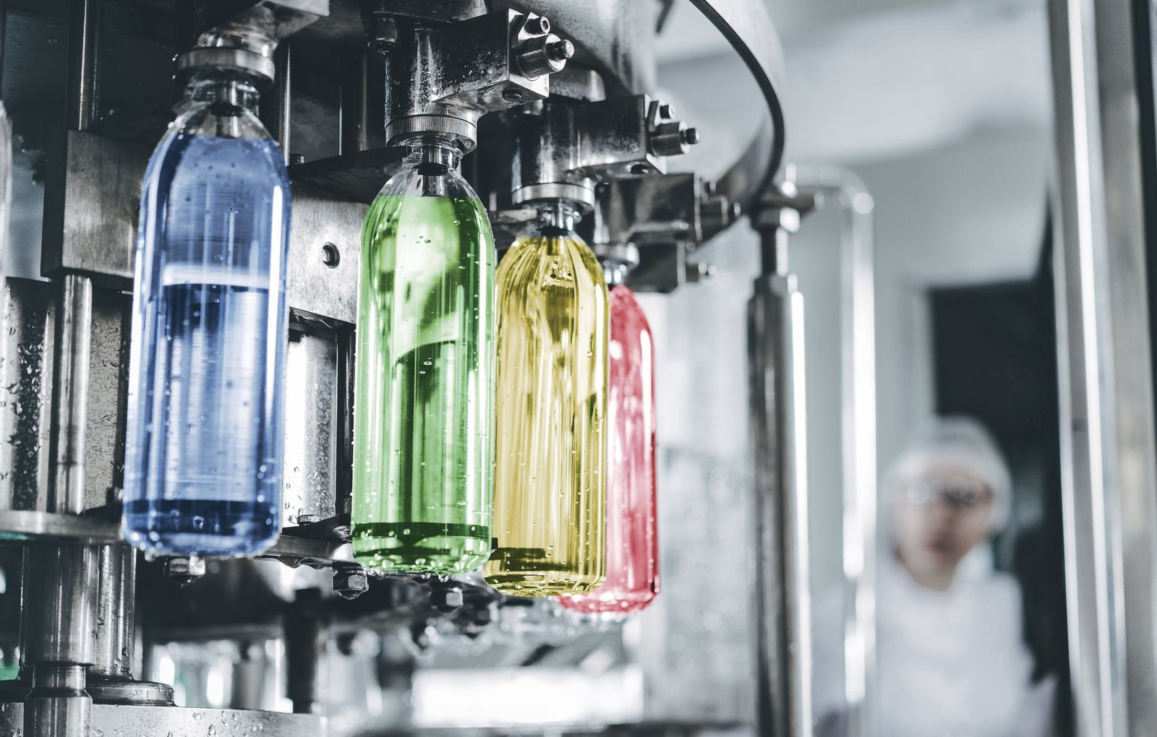
At this year's interpack, 18 machines show how companies are staying resilient and building competitive edge with rapid changeover and quick time to market – the best place to start is right at the B&R booth.
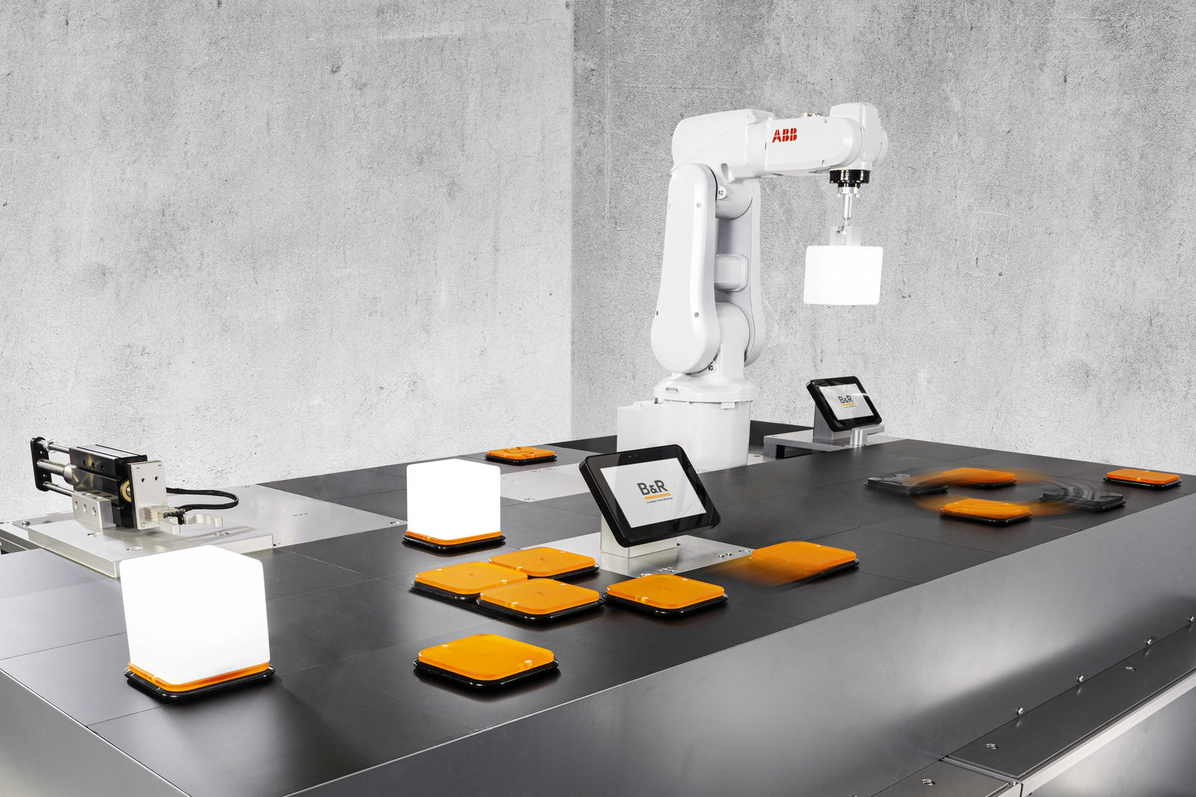
B&R's ACOPOS 6D is ideal for producing small batches of products with constantly changing designs. The magnetically levitating shuttles move each product individually through the machine with six degrees of freedom.
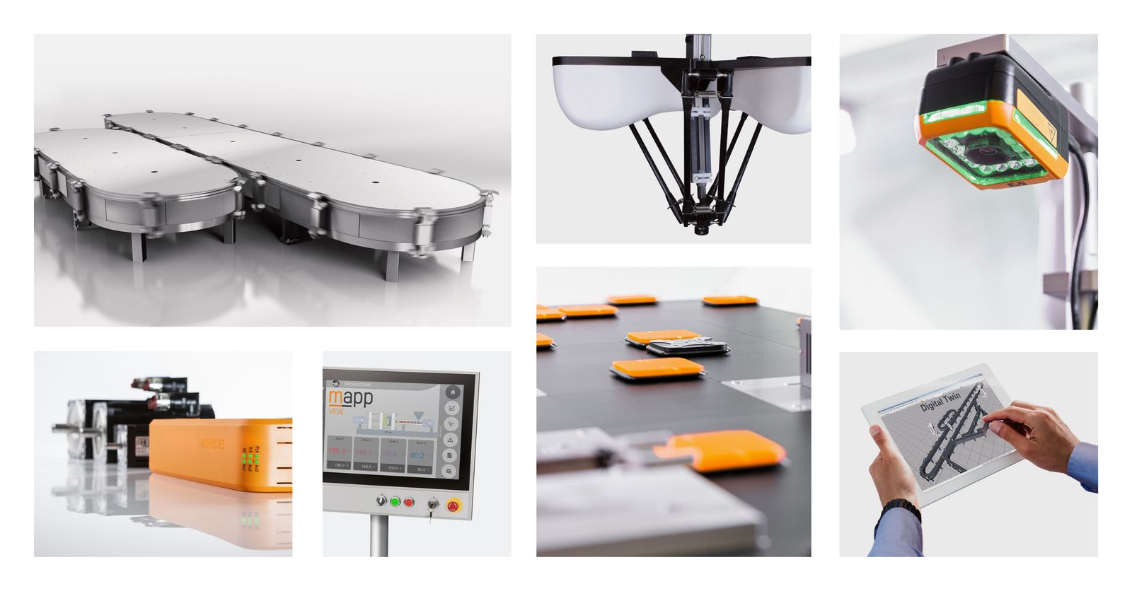
Live demonstrations at the B&R booth show what is possible when mechatronic product transport is combined with robotics, vision and simulation – and powered by B&R's open and integrated control solutions.
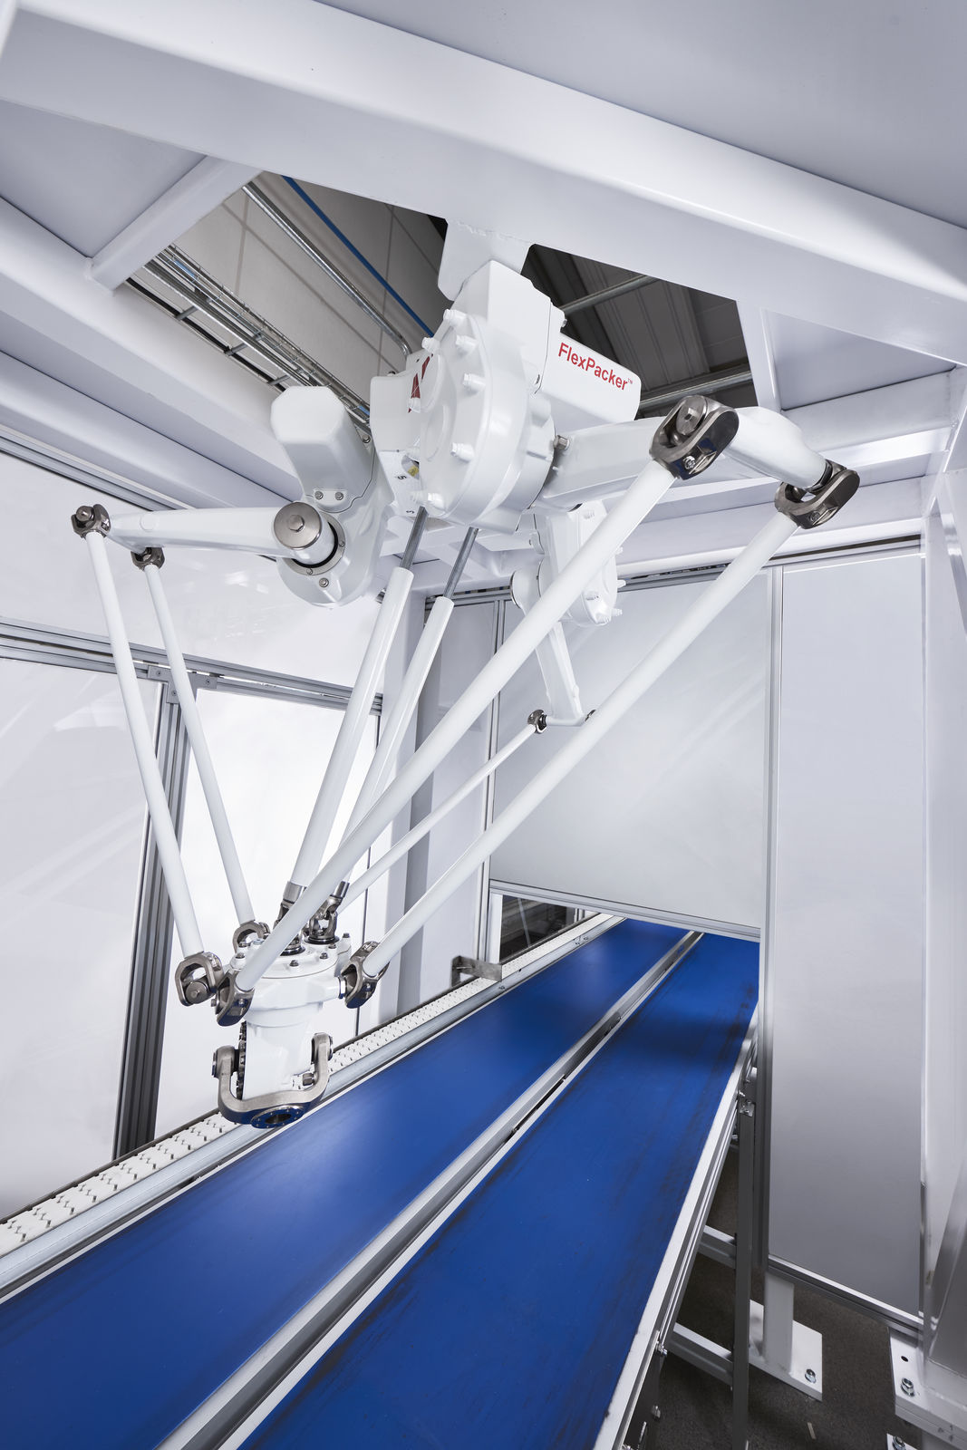
Delta robots like ABB's FlexPacker IRB 390 offer exceptional flexibility, speed and precision.
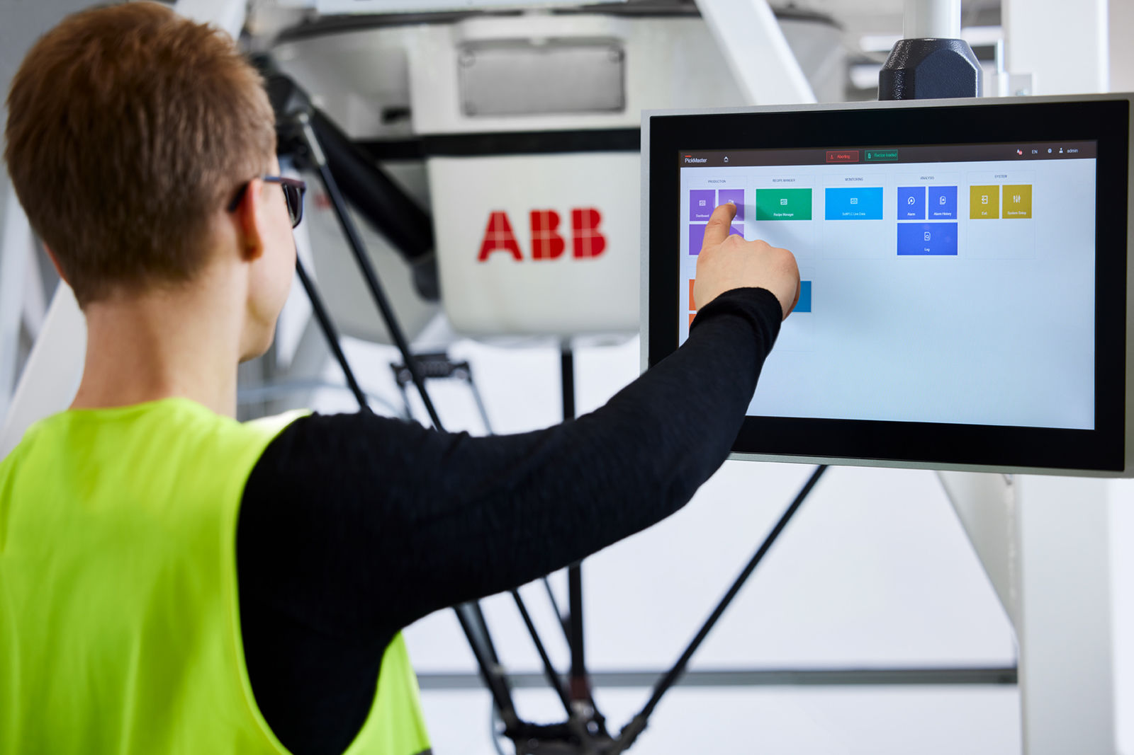
At interpack, ABB will also be showing its portfolio of software solutions, including the latest version of PickMaster® Twin – the market-leading robotics software for camera-supported pick and pack solutions.
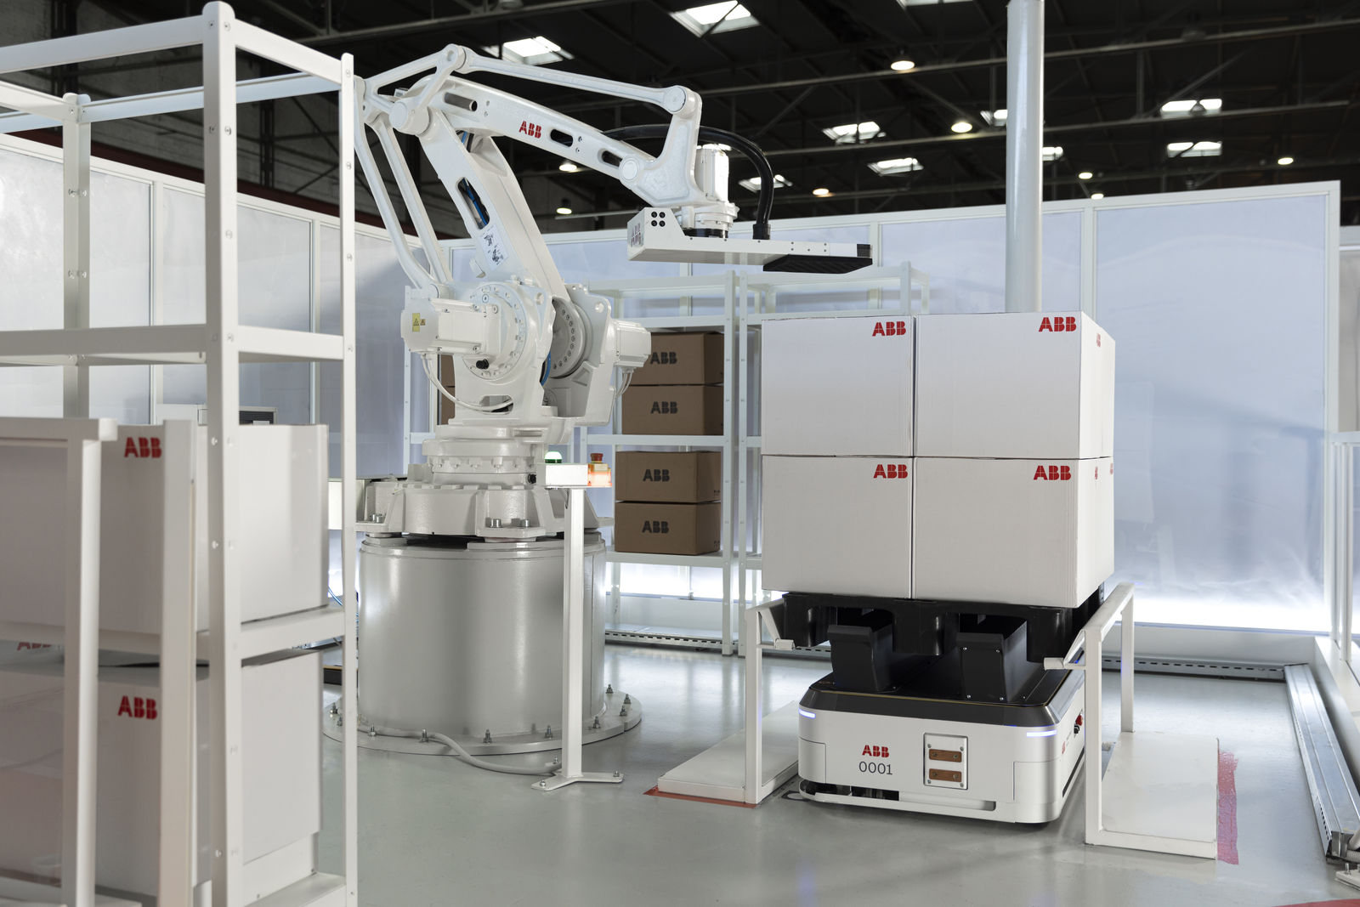
The ABB booth (Hall 6, Booth B74) at this year's interpack will showcase intelligent automated packaging solutions, including sequencing and pallet loading and unloading – using autonomous mobile robots (AMR).

About B&R
B&R is an innovative automation company with headquarters in Austria and offices all around the world. On July 6, 2017, B&R became a business unit of the ABB Group. As a global leader in industrial automation, B&R combines state-of-the-art technology with advanced engineering to provide customers in virtually every industry with complete solutions for machine and factory automation, motion control, HMI and integrated safety technology. With Industrial IoT communication standards like OPC UA, POWERLINK and openSAFETY as well as the powerful Automation Studio software development environment, B&R is constantly redefining the future of automation engineering. The innovative spirit that keeps B&R at the forefront of industrial automation is driven by a commitment to simplifying processes and exceeding customer expectations.
For more information, visit www.br-automation.com.

