Technology – and engineers – of tomorrow
B&R supports three teams at Smart Green Island Makeathon
Under the motto "Make, create & have fun", more than 200 students from 23 nations met in Gran Canaria from March 1-4 after a two-year break. When completing the tasks at the Smart Green Island Makeathon, interdisciplinary teams developed forward-looking solutions to issues such as upcycling plastic waste into 3D printing material, generating solar energy more efficiently or promoting seaweed as a sustainable raw material. As in previous years, the event was organized by the engineering and consulting company ITQ.
The aim of the international event is to draw attention to topics such as environmental pollution and the energy transition and also to counteract the prevailing shortage of skilled workers. Under the Spanish sun, students from 11 educational institutions in different countries received B&R hardware and support from a team on site to help them implement their projects.
4 days of innovation and sustainability
Under the direction of the Kempten and Bremerhaven universities (both in Germany), one of B&R's teams designed a machine that crushes used PET bottles, melts them down and then extrudes them as filament – a plastic thread – for 3D printing. Then, 3D printers can create three-dimensional workpieces from the plastic filament.
Another B&R-supported team built an intelligent solar module under the responsibility of the University of Applied Sciences in Vienna. Using data from a cloud server, the solar panels track the position of the sun to maximize energy output.
Solving waste and worker shortage
The upcycling solution helps reduce the amount of plastic waste that ends up in the world's oceans and landfills. The Smart Green Island Makeathon is designed to get young people excited about automation technology and at the same time to encourage them to think about sustainability. "I think the concept of the makeathon is really excellent," says Patrick Haberstroh, head of B&R's Education Network. "There are a lot of innovative ideas emerging here that we desperately need."
"We've noticed a decline in interest for technology among young people," notes Haberstroh. B&R has long been committed to training and education.. Haberstroh adds: "It's important to us to get young people more engaged with technology, because industries urgently need the next generation of technicians and engineers. That's why we're at this event, where the goal is to generate and prototype a number of innovative ideas in a short period of time."
Regarding the motivation of the teams, Haberstroh says: "I'm always amazed by the students self-motivation and their drive to complete the projects on time. The Makeathon is the perfect way to meet young talent from all over the world, connect with them early and be inspired by their motivation."
In addition, the budding engineers, programmers and designers get a taste of real life as an engineer at the Makeathon. They have to solve a complex task in a defined period of time together with an international team they've never met. This involves overcoming language barriers, but also cultural, emotional and interpersonal hurdles. "Their experience handling these challenges helps prepare them for similar challenges that await them in the real workplace," says Haberstroh.
What is a makeathon?
A makeathon is an interactive platform for young people who want to make a difference. The combination of "To make" and "Marathon" clearly show what the creative format is all about: Agile teams with young talent develop innovative concepts and prototypes in a short time. The focus is on working together to complete tasks, which are specified by companies that provide hardware, software and relevant know-how.

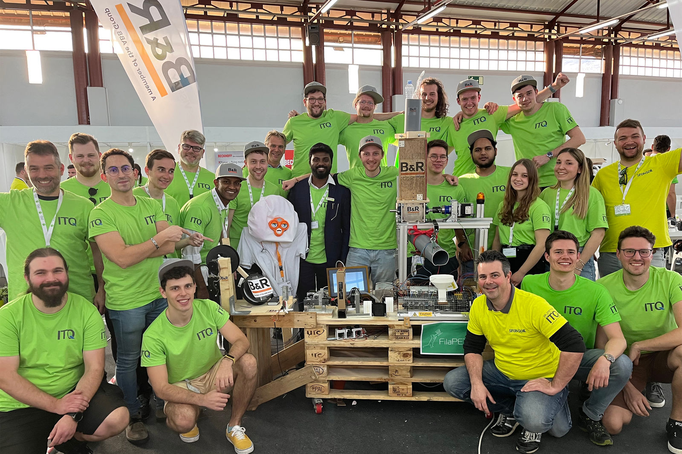
For four days, B&R provided on-site support for three teams from Germany, Italy and India together with Patrick Haberstroh, Head of B&R's Education Network (front right)

About B&R
B&R is an innovative automation company with headquarters in Austria and offices all around the world. On July 6, 2017, B&R became a business unit of the ABB Group. As a global leader in industrial automation, B&R combines state-of-the-art technology with advanced engineering to provide customers in virtually every industry with complete solutions for machine and factory automation, motion control, HMI and integrated safety technology. With Industrial IoT communication standards like OPC UA, POWERLINK and openSAFETY as well as the powerful Automation Studio software development environment, B&R is constantly redefining the future of automation engineering. The innovative spirit that keeps B&R at the forefront of industrial automation is driven by a commitment to simplifying processes and exceeding customer expectations.
For more information, visit www.br-automation.com.

