For the safety of employees, customers and partners
B&R bows out of SPS, unveils virtual showroom
B&R has canceled its participation in the SPS smart production solutions 2021 trade fair in Nuremberg. "We want to protect the health of our employees, customers and partners and do what we can to slow the spread of the pandemic," says Markus Sandhöfner, managing director of B&R Germany.
"A trade fair brings thousands of people together in a relatively tight space. The higher the local infection rate and the more people coming into contact, the higher the risk of infection – even with the best hygienic measures," says Sandhöfner. "With the number of COVID-19 cases increasing rapidly, particularly in Bavaria, we deem it inappropriate to participate in large events at the moment – although we dearly miss the personal contact with our customers and interested visitors."
Information about B&R products and solutions can be found in the company's new virtual showroom at experience.br-automation.com. "There, visitors can enjoy a virtual experience of how automation will shape the future of manufacturing," says Sandhöfner. "Of course, we are always available to talk one-on-one about our solutions and innovations. Anyone who doesn't yet have a B&R contact can easily find the right person on our website under Contact."

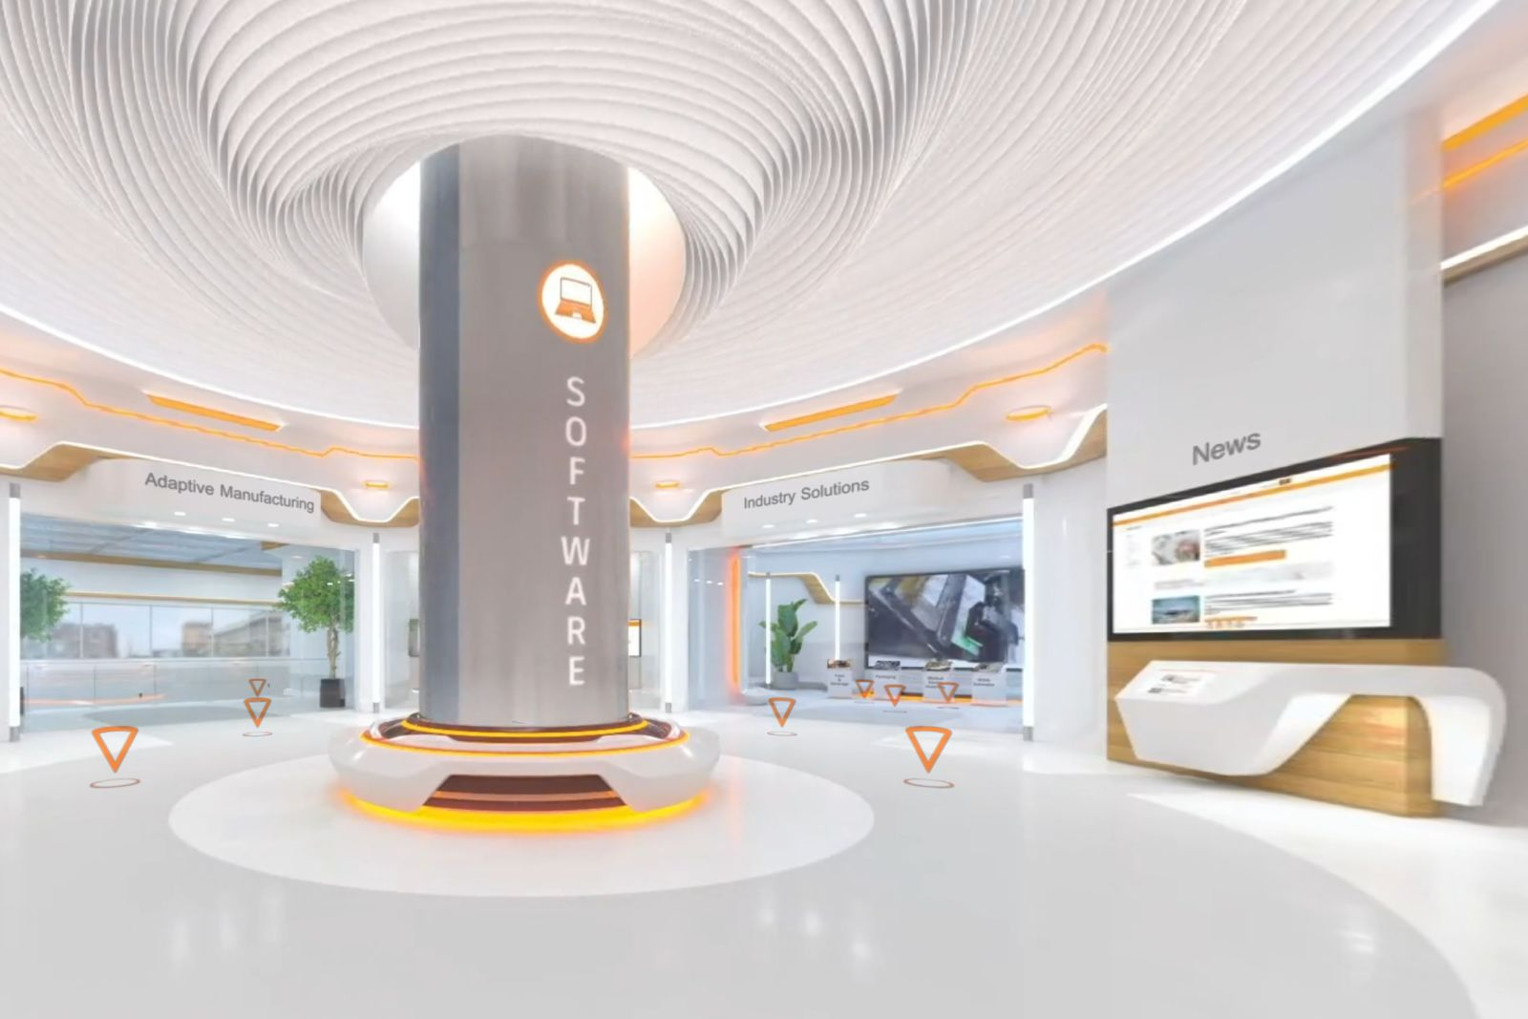
B&R has opened a virtual showroom, where visitors can experience B&R products and solutions up close from anywhere in the world.

About B&R
B&R is an innovative automation company with headquarters in Austria and offices all around the world. On July 6, 2017, B&R became a business unit of the ABB Group. As a global leader in industrial automation, B&R combines state-of-the-art technology with advanced engineering to provide customers in virtually every industry with complete solutions for machine and factory automation, motion control, HMI and integrated safety technology. With Industrial IoT communication standards like OPC UA, POWERLINK and openSAFETY as well as the powerful Automation Studio software development environment, B&R is constantly redefining the future of automation engineering. The innovative spirit that keeps B&R at the forefront of industrial automation is driven by a commitment to simplifying processes and exceeding customer expectations.
For more information, visit www.br-automation.com.

