More safety for mobile machinery
B&R introduces new safety relay module for X90 control system
Mobile machines are becoming increasingly autonomous. They require controllers that are not only compact, but also safe. B&R has expanded its X90 control system with an option board that allows floating-ground connection of external safety devices, making mobile machines even safer.
Mobile controllers with safe, floating outputs have previously not been available on the market. With B&R's new safety relay module, external safety components such as drives or laser scanners can now be connected to the X90 controller via a floating-ground emergency stop circuit. A safety level of PLe / SIL3 can be achieved. The option board is particularly suitable for autonomous agricultural and construction vehicles.
Modularity makes the difference
With its powerful, expandable X90 controller, B&R offers design freedom that is unique on the market. The range of option boards opens up new possibilities for implementing customer-specific automation solutions. In addition, the controller comes in a rugged IP69K housing. Since it does not require a control cabinet or complex wiring, easy service is guaranteed.

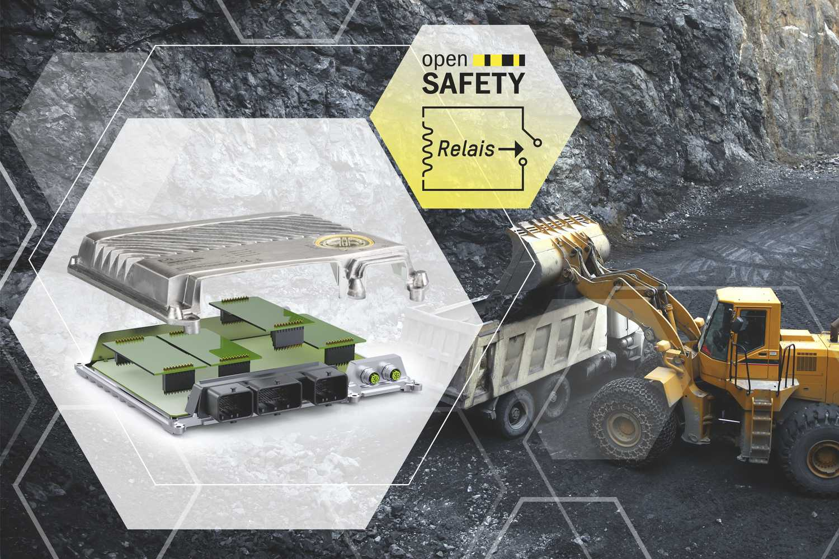
The new safety relay module from B&R makes mobile machinery even safer.

About B&R
B&R is an innovative automation company with headquarters in Austria and offices all around the world. On July 6, 2017, B&R became a business unit of the ABB Group. As a global leader in industrial automation, B&R combines state-of-the-art technology with advanced engineering to provide customers in virtually every industry with complete solutions for machine and factory automation, motion control, HMI and integrated safety technology. With Industrial IoT communication standards like OPC UA, POWERLINK and openSAFETY as well as the powerful Automation Studio software development environment, B&R is constantly redefining the future of automation engineering. The innovative spirit that keeps B&R at the forefront of industrial automation is driven by a commitment to simplifying processes and exceeding customer expectations.
For more information, visit www.br-automation.com.

