More safety for less money
B&R servo drive with integrated torque determination reduces costs
B&R has equipped the ACOPOS P3 servo drive with safe torque determination. This allows the use of numerous safety functions that previously would have required an external sensor. The cost of machinery directive compliance is reduced.

Safe torque determination is based on an internal current measurement and enables the safety functions Safely Limited Torque (SLT), Safe Speed Observer (SSO) and Safe Brake Test (SBT). The functions are suitable for applications up to SIL 2 / PL d / Cat. 3.
Safe prevention of overload
The SLT function can be used, for example, to reliably limit the torque applied to the power transmission system. Mechanical overload conditions can thus be avoided and safely averted. In addition, mechanical designs can be made more cost-effective with SLT. SLT also minimizes the risk of operators being injured via pinching or crushing while working on a machine.
Ensuring operator safety
The SSO function is a virtual speed sensor that makes it possible to use the SLS safety function without needing a safe encoder. This is particularly helpful when using linear or torque motors, since these types of motors usually do not have an integrated safe encoder.
Reliable holding brake testing
The SBT function can be used to safely monitor and evaluate the performance of a holding brake. The data it collects provides insight into the condition of the brake and any damage or wear.

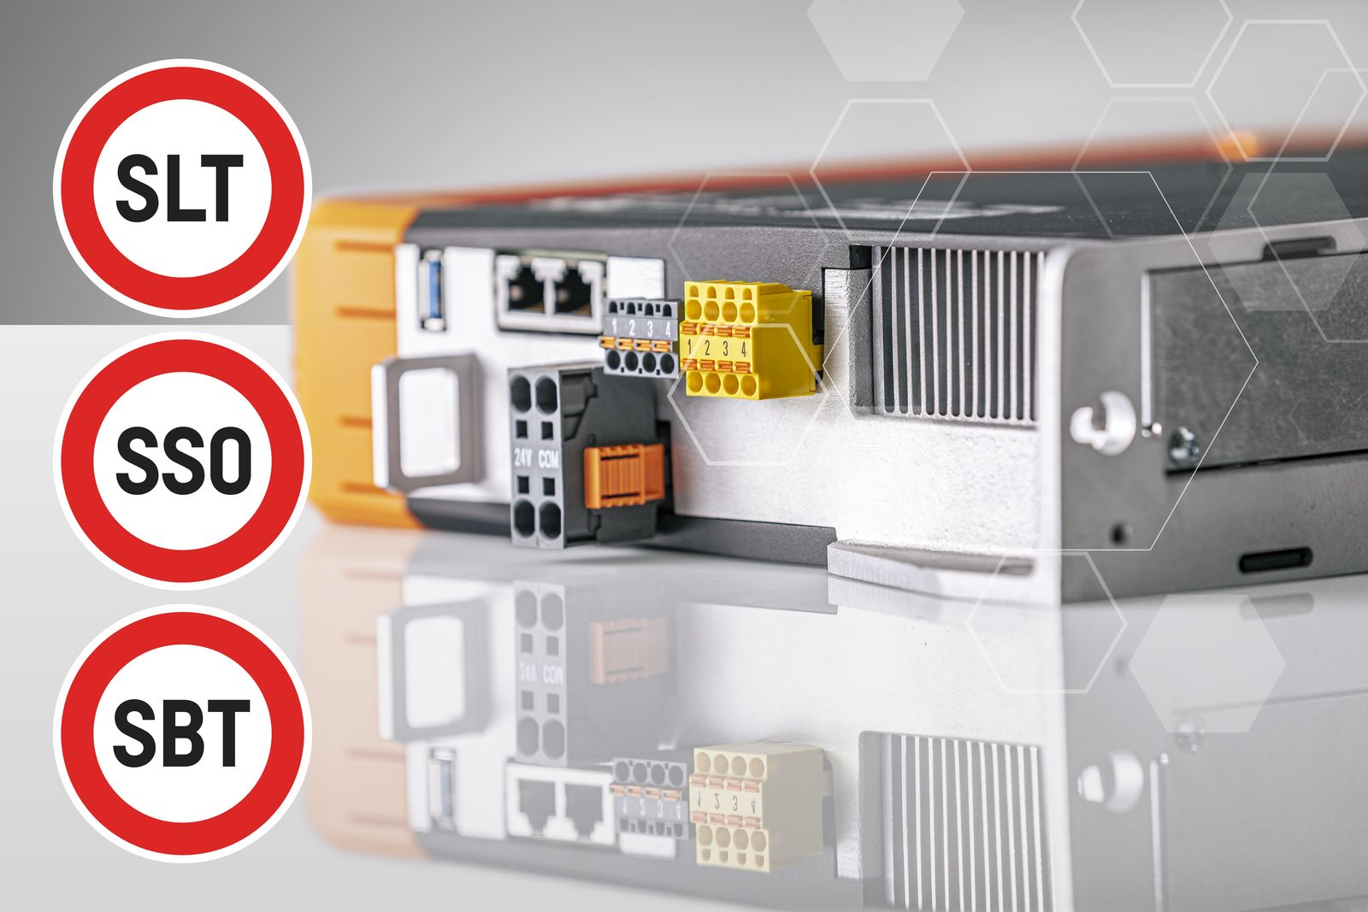
B&R has equipped the ACOPOS P3 servo drive with safe torque determination, enabling numerous integrated safety functions.

About B&R
B&R is an innovative automation company with headquarters in Austria and offices all around the world. On July 6, 2017, B&R became a business unit of the ABB Group. As a global leader in industrial automation, B&R combines state-of-the-art technology with advanced engineering to provide customers in virtually every industry with complete solutions for machine and factory automation, motion control, HMI and integrated safety technology. With Industrial IoT communication standards like OPC UA, POWERLINK and openSAFETY as well as the powerful Automation Studio software development environment, B&R is constantly redefining the future of automation engineering. The innovative spirit that keeps B&R at the forefront of industrial automation is driven by a commitment to simplifying processes and exceeding customer expectations.
For more information, visit www.br-automation.com.

