Perfect motion control for every application
B&R expands motor selection with Hiperface DSL Safety
The safety functions of the B&R ACOPOS P3 servo drive are now also available for motors with a safe Hiperface DSL encoder. Machine builders now have a broader selection of motors when implementing safe motion control applications.

Hiperface DSL Safety has established itself on the market alongside EnDat 2.2 Safety as a leading industry standard for safe data transfer between motors and servo drives. Just like EnDat 2.2, HDSL Safety is compatible with all B&R safety functions. That includes functions such as Safely Limited Speed (SLS), Safe Operating Stop (SOS) and Safe Limited Increment (SLI).
For every application
HDSL Safety support is available with an easy firmware update. The encoder type is defined by parameters on the servo drive's safety module. Modules can be combined freely, regardless of whether they were configured with EnDat 2.2 or with HDSL Safety. Application developers are able to choose the best encoder system for any given application.

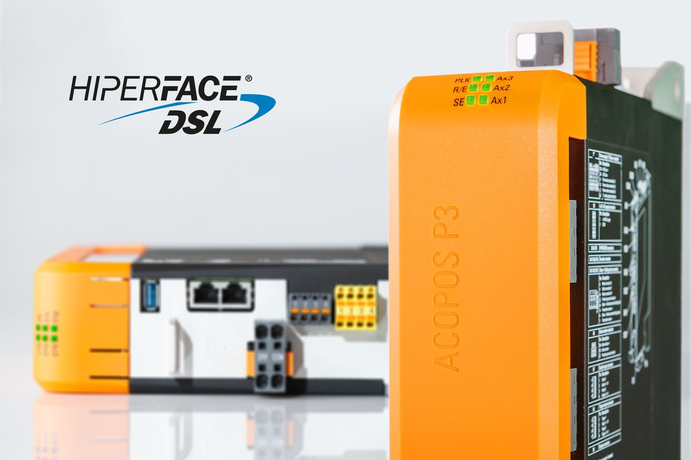
The safety functions of the B&R ACOPOS P3 servo drive are now also available for motors with a safe Hiperface DSL encoder.

About B&R
B&R is an innovative automation company with headquarters in Austria and offices all around the world. On July 6, 2017, B&R became a business unit of the ABB Group. As a global leader in industrial automation, B&R combines state-of-the-art technology with advanced engineering to provide customers in virtually every industry with complete solutions for machine and factory automation, motion control, HMI and integrated safety technology. With Industrial IoT communication standards like OPC UA, POWERLINK and openSAFETY as well as the powerful Automation Studio software development environment, B&R is constantly redefining the future of automation engineering. The innovative spirit that keeps B&R at the forefront of industrial automation is driven by a commitment to simplifying processes and exceeding customer expectations.
For more information, visit www.br-automation.com.

