HMI to go
Seamless handoff to mobile devices for uninterrupted productivity
Machine operators can now pass control of their machine seamlessly between the main HMI and their mobile devices. A new feature of B&R's mapp View HMI solution ensures that the controls and information they need are always at their fingertips, so they can move freely around the plant floor as they continue working.
"Until now, HMI terminals have restricted machine operators to working within a certain radius," explains B&R software expert Manuel Sánchez. "If they can't reach the screen, they can't control the machine." B&R's web-based HMI solution now enables them to take control of the machine with them on their mobile device wherever they need to go. Once the task is complete, they simply pass control back to the main HMI.
The new QRViewer widget available in B&R's mapp View HMI solution generates dynamic QR codes in the machine's user interface. In addition to handing off HMI operation to a smartphone, these codes enable a variety of other convenient new features to optimize machine performance and availability.
Faster response times
In the event of an error in the system, operators can quickly access help documentation, instructional videos, part numbers and more – right on their smartphone. When viewing historical performance data, they can access higher-level ERP systems and track batches throughout the entire supply chain. The right information, in the right place, at the right time helps keep the machine producing safely with minimal downtime.

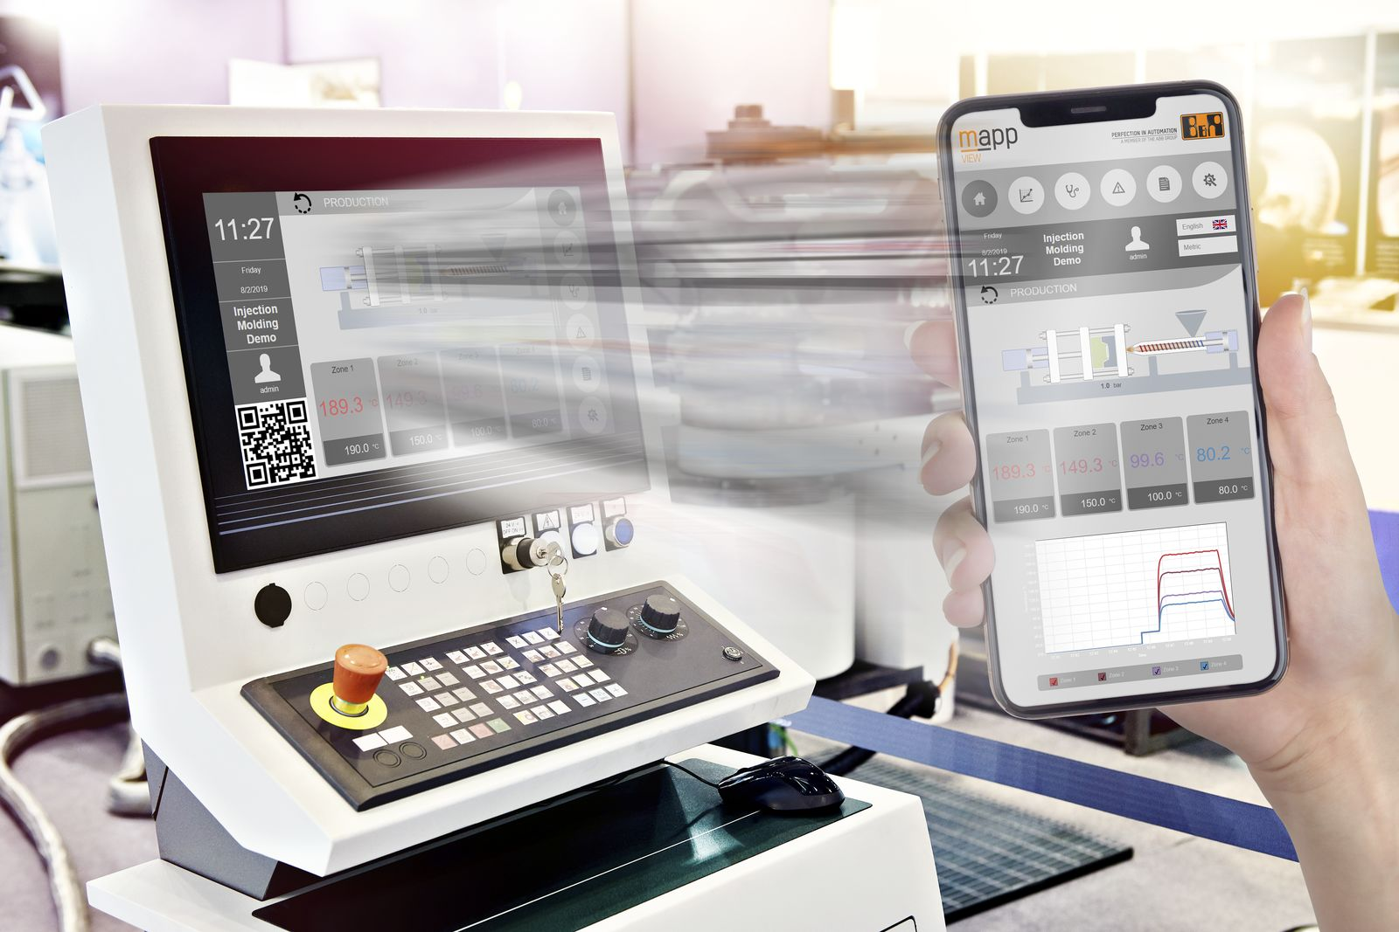
Machine operators can now hand off control of the machine from the main HMI to their mobile device and move freely around the plant floor as they continue working.

About B&R
B&R is an innovative automation company with headquarters in Austria and offices all around the world. On July 6, 2017, B&R became a business unit of the ABB Group. As a global leader in industrial automation, B&R combines state-of-the-art technology with advanced engineering to provide customers in virtually every industry with complete solutions for machine and factory automation, motion control, HMI and integrated safety technology. With Industrial IoT communication standards like OPC UA, POWERLINK and openSAFETY as well as the powerful Automation Studio software development environment, B&R is constantly redefining the future of automation engineering. The innovative spirit that keeps B&R at the forefront of industrial automation is driven by a commitment to simplifying processes and exceeding customer expectations.
For more information, visit www.br-automation.com.

