Setting the stage for seamless connectivity
Hannover Messe: New B&R portfolio with OPC UA over TSN
At the Hannover Messe (Hall 9 / Booth D26), B&R will be the first to present an automation portfolio that speaks OPC UA over TSN. And with that, the vision of interface free communication from the sensor to the cloud is now a reality. The open standard means OEMs are no longer locked in to a specific vendor and enjoy greater freedom in the design of their machines. Another exhibition highlight will be B&R's full integration of robotics in the machine control system.
The unified communication standard OPC UA over TSN allows components from different manufacturers to be combined at will. Replacing a multitude of competing protocols with OPC UA over TSN communication makes machine development both easier and more agile. The new B&R portfolio sets the stage for OEMs to start enjoying the benefits of the open standard today. Visitors to the B&R booth can dive into the world of OPC UA over TSN and experience seamless connectivity first hand.
Switch to the new standard
In addition to X20 PLCs, a bus controller, industrial PCs and panel PCs, B&R's OPC UA over TSN portfolio also includes a TSN switch. Automatic switch configuration in Automation Studio saves time, making machine development not only more flexible, but faster as well.
The robot in the heart of the machine
Setting up robots and synchronizing them with the rest of the machine has traditionally been a complex, difficult process. At the Hannover Messe, B&R will demonstrate how robots are now just as easy to implement as any other automation component. There is no longer any need for a dedicated robotics controller, extra control cabinet or separate robotics application.

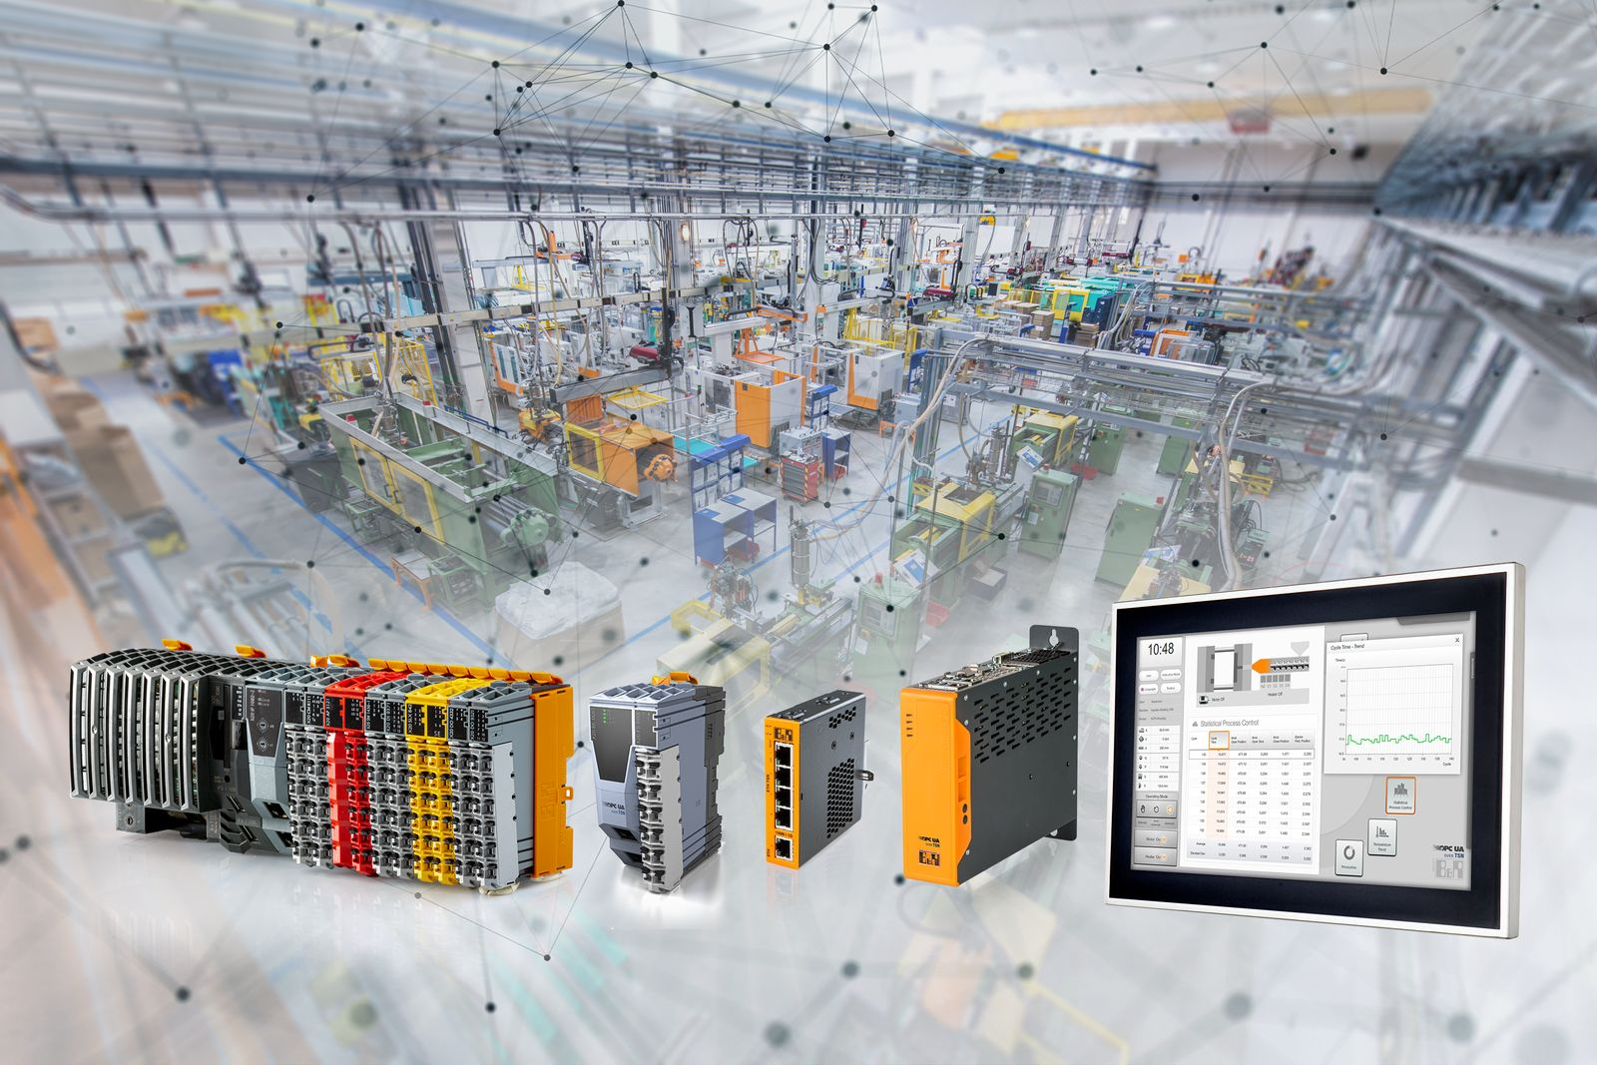
The Hannover Messe was cancelled in 2020 due to the Covid 19 pandemic.

About B&R
B&R is an innovative automation company with headquarters in Austria and offices all around the world. On July 6, 2017, B&R became a business unit of the ABB Group. As a global leader in industrial automation, B&R combines state-of-the-art technology with advanced engineering to provide customers in virtually every industry with complete solutions for machine and factory automation, motion control, HMI and integrated safety technology. With Industrial IoT communication standards like OPC UA, POWERLINK and openSAFETY as well as the powerful Automation Studio software development environment, B&R is constantly redefining the future of automation engineering. The innovative spirit that keeps B&R at the forefront of industrial automation is driven by a commitment to simplifying processes and exceeding customer expectations.
For more information, visit www.br-automation.com.

