Double the storage capacity
B&R adds new compact PLC to Compact-S series
B&R is offering a new Compact-S PLC with 512 MB of RAM and 2 GB of internal flash memory. That gives the X20CP0484-1 more than twice the RAM capacity of previous models from the Compact-S series. It is ideal for applications with high requirements for memory and performance.

With a width of only 37.5 mm including the power supply, the X20CP0484-1 is a part of B&R's compact PLC portfolio. With Ethernet, POWERLINK, USB and RS232, it offers plenty of communication options. An optional CAN interface is also available. With no fans or batteries, the PLC is also maintenance free.
Sleek automation solution
X20 I/O modules can be connected directly to the controller and line up seamlessly. The entire system saves a large amount of space in the control cabinet. Even with its narrow dimensions, the controller has a built-in power supply for itself and the connected I/O modules. There is no need for a separate power supply module.

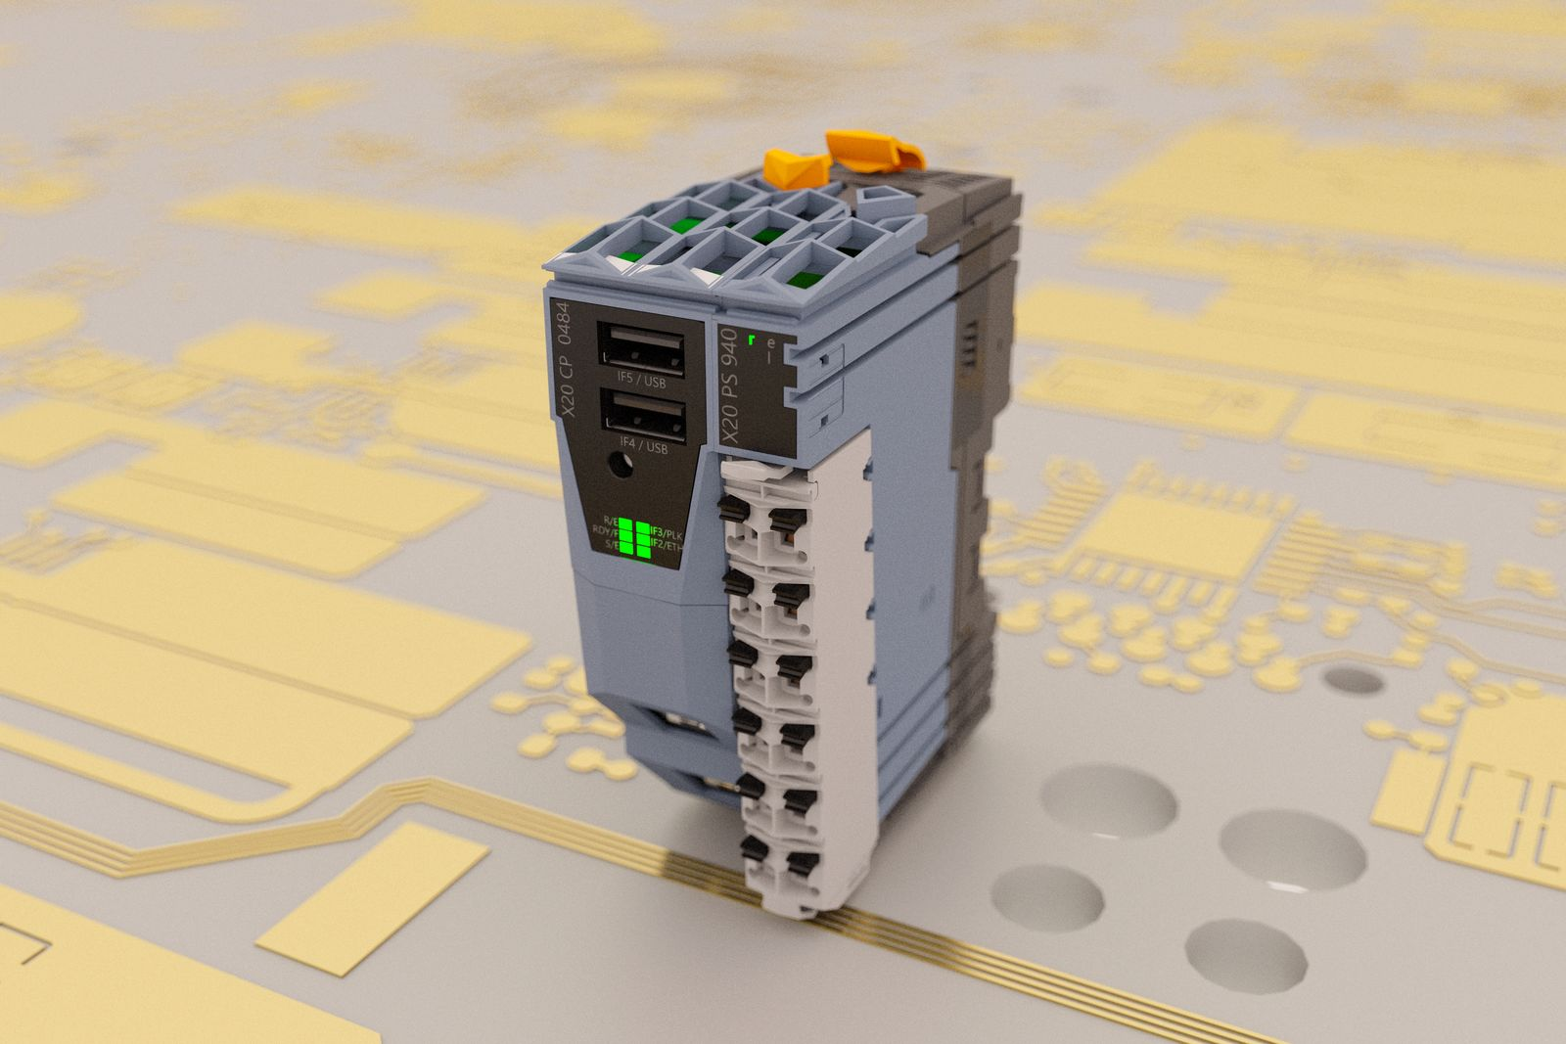
B&R's new compact PLC offers twice the RAM of previous models from the Compact-S series.

About B&R
B&R is an innovative automation company with headquarters in Austria and offices all around the world. On July 6, 2017, B&R became a business unit of the ABB Group. As a global leader in industrial automation, B&R combines state-of-the-art technology with advanced engineering to provide customers in virtually every industry with complete solutions for machine and factory automation, motion control, HMI and integrated safety technology. With Industrial IoT communication standards like OPC UA, POWERLINK and openSAFETY as well as the powerful Automation Studio software development environment, B&R is constantly redefining the future of automation engineering. The innovative spirit that keeps B&R at the forefront of industrial automation is driven by a commitment to simplifying processes and exceeding customer expectations.
For more information, visit www.br-automation.com.

