Full safety following network failure
B&R's Blackout mode enables high machine availability
The B&R drive technology portfolio now offers a Blackout mode. This enables safe machine control in the event of a network failure. Machine downtime can be avoided without costly redundancy solutions to ensure maximum machine availability.

The Blackout function enables the safe variants of B&R servo drives (ACOPOSmulti, ACOPOSmotor or ACOPOS P3) to continue operation in the event of a network failure. Safety functionality remains intact.
Controlled shutdown
Blackout mode allows configuration of simple safety sequences. Applications in lower-level systems continue execution even after a network failure. For example, axes can be brought to a stop or moved to a defined position.

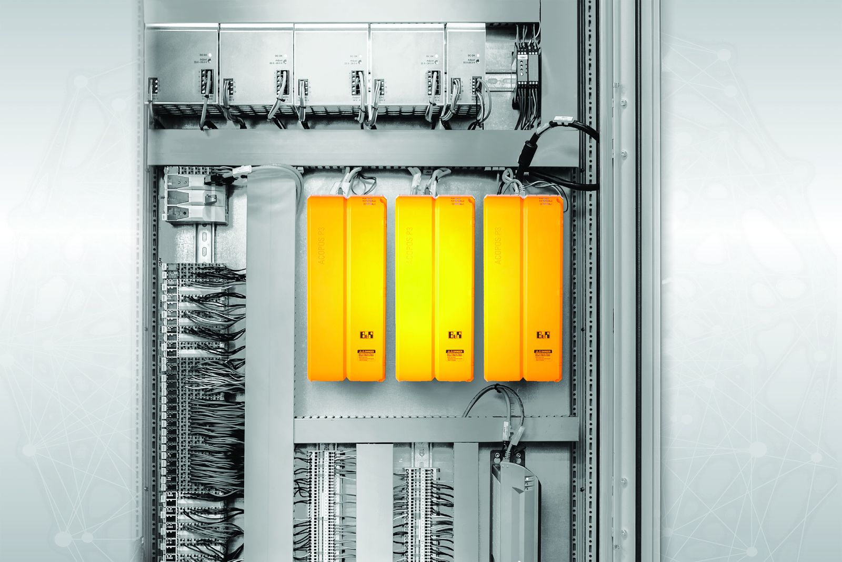
The B&R drive technology portfolio now offers a Blackout mode.

About B&R
B&R is an innovative automation company with headquarters in Austria and offices all around the world. On July 6, 2017, B&R became a business unit of the ABB Group. As a global leader in industrial automation, B&R combines state-of-the-art technology with advanced engineering to provide customers in virtually every industry with complete solutions for machine and factory automation, motion control, HMI and integrated safety technology. With Industrial IoT communication standards like OPC UA, POWERLINK and openSAFETY as well as the powerful Automation Studio software development environment, B&R is constantly redefining the future of automation engineering. The innovative spirit that keeps B&R at the forefront of industrial automation is driven by a commitment to simplifying processes and exceeding customer expectations.
For more information, visit www.br-automation.com.

