Multitenancy for B&R cloud application
Asset Performance Monitor opens up new OEM business models
Manufacturing OEMs can now also provide data and results from Asset Performance Monitor to their customers, opening up new revenue streams. The cloud application also configures itself – regardless of the type and number of connected machines.

Asset Performance Monitor now automatically recognizes assigned edge devices and the corresponding machines. The application collects available data via OPC UA. Thanks to OPC UA semantic descriptions and industry-specific standards like PackML and EUROMAP 77, Asset Performance Monitor knows how to prepare the data. Without any configuration at all, the user can view dashboards, reports and alarm overviews. Even small and midsized OEMs now have access to comprehensive IoT solutions.
New business models for OEMs
B&R has made its Asset Performance Monitor multitenant. With the ability to process data from their machines and sell the resulting data back to their customers, OEMs can now implement new business models. The machine builder simply makes the corresponding settings in Asset Performance Monitor – no additional hardware or software is required.
Asset Performance Monitor
Around the clock and around the world, the Asset Performance Monitor cloud application collects data – such as performance metrics, energy consumption and production rates – and presents it in clearly structured reports and dashboards. This makes it possible to reduce unplanned downtime as well as to detect and prevent production bottlenecks. Asset Performance Monitor is based on a flexible IoT platform that enables it to be expanded quickly and easily.

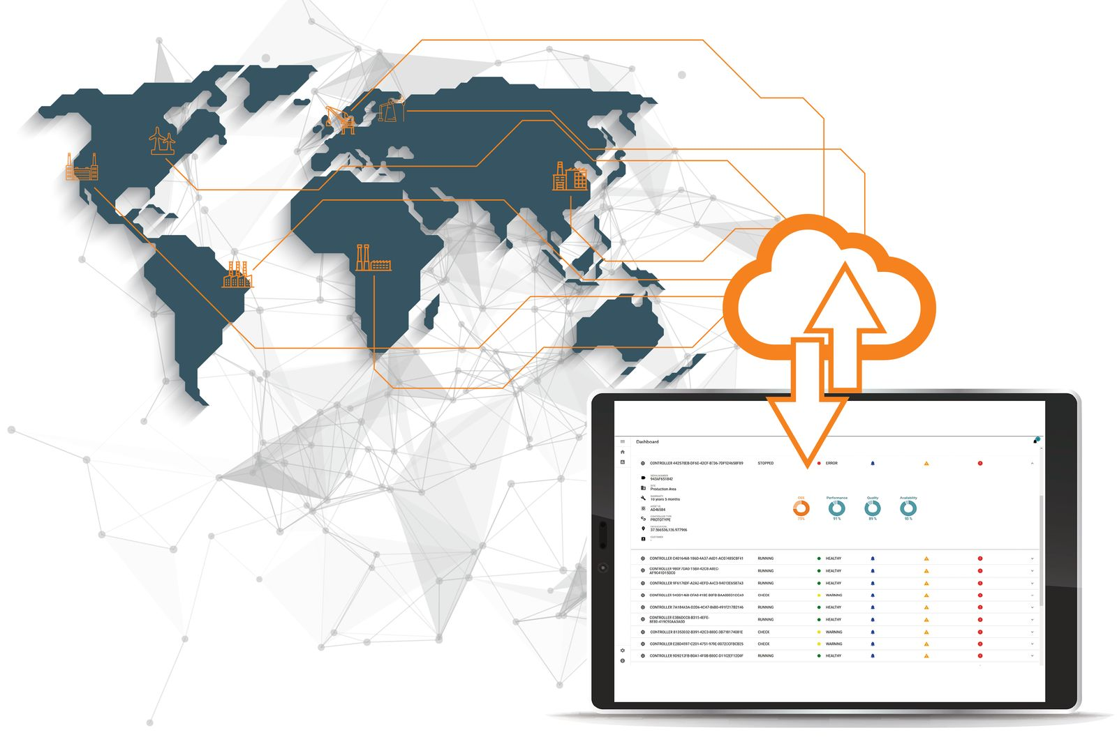
With the ability to process data from their machines and sell the resulting data back to their customers, OEMs can now implement new business models.

About B&R
B&R is an innovative automation company with headquarters in Austria and offices all around the world. On July 6, 2017, B&R became a business unit of the ABB Group. As a global leader in industrial automation, B&R combines state-of-the-art technology with advanced engineering to provide customers in virtually every industry with complete solutions for machine and factory automation, motion control, HMI and integrated safety technology. With Industrial IoT communication standards like OPC UA, POWERLINK and openSAFETY as well as the powerful Automation Studio software development environment, B&R is constantly redefining the future of automation engineering. The innovative spirit that keeps B&R at the forefront of industrial automation is driven by a commitment to simplifying processes and exceeding customer expectations.
For more information, visit www.br-automation.com.

