The power of a PC
B&R's industrial controllers take performance to a whole new level.
The new B&R X20CP3687X controller combines the performance of an industrial PC with the compact design of the X20 controller series. With powerful processing, additional RAM and integrated onboard flash memory, the high-performance controller can handle complex control algorithms or even robotics applications that previously would have called for an industrial PC.

With a TSN-enabled Ethernet interface, the X20CP3687X is well-equipped for the future. It is fully prepared for communication using the manufacturer-independent communication standard OPC UA over TSN. The controller comes standard with connections for USB and POWERLINK.
Additional interfaces can be added via interface modules. Despite its powerful capabilities, the new module has exactly the same design and dimensions as all the other controllers in B&R's X20 series.

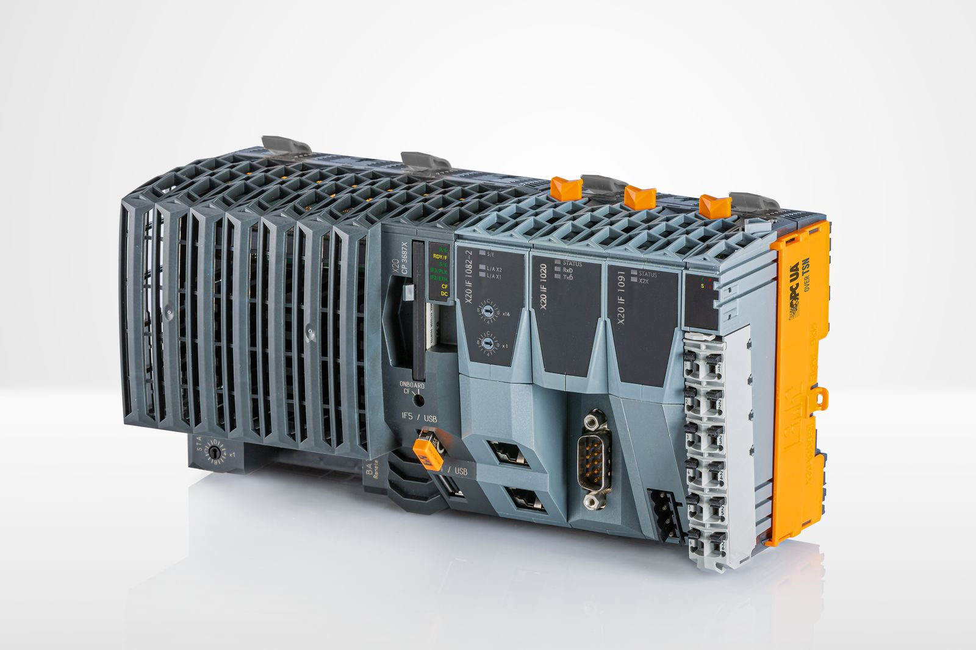
B&R's X20CP3687X controller combines the performance of an industrial PC with the compact design of the X20 controller series.

About B&R
B&R is an innovative automation company with headquarters in Austria and offices all around the world. On July 6, 2017, B&R became a business unit of the ABB Group. As a global leader in industrial automation, B&R combines state-of-the-art technology with advanced engineering to provide customers in virtually every industry with complete solutions for machine and factory automation, motion control, HMI and integrated safety technology. With Industrial IoT communication standards like OPC UA, POWERLINK and openSAFETY as well as the powerful Automation Studio software development environment, B&R is constantly redefining the future of automation engineering. The innovative spirit that keeps B&R at the forefront of industrial automation is driven by a commitment to simplifying processes and exceeding customer expectations.
For more information, visit www.br-automation.com.

