ACOPOStrak for washdown
IP69K-rated track system for industries with strict cleanability requirements
B&R now offers an IP69K-rated variant of its intelligent ACOPOStrak track system. The new version of the track can be pressure washed at temperatures of up to 80°C. This makes it suitable for use in industries like food and beverages and pharmaceuticals with the highest demands on cleanability.

Not only is the new track protected against high-pressure cleaning, it is also completely protected against dust. With IP69K protection, the track system is perfect for primary packaging applications. It can be used in both dry and wet areas of complex installations.
Corrosion protection for shuttles and segments
The shuttles and segments of the new track variant are made of stainless steel, securely welded and thus resistant to corrosion. The stainless steel housing enables the transport of corrosive products and operation of the ACOPOStrak in corrosive atmospheres such as salt spray. All of the track's surfaces are chemically resistant, preventing particles or fluids from penetrating into the interior of the shuttle or segments. The shuttles' magnet unit is completely protected against high-pressure cleaning.
Absolute flexibility
With the IP69K version of the ACOPOStrak, B&R enables economical batch-size-one operation with the efficiency of mass production – even for industries with strict cleanability requirements. ACOPOStrak can be expanded flexibly by adding track modules and processing stations. This makes machines scalable enough to adapt to changing production requirements at any time.

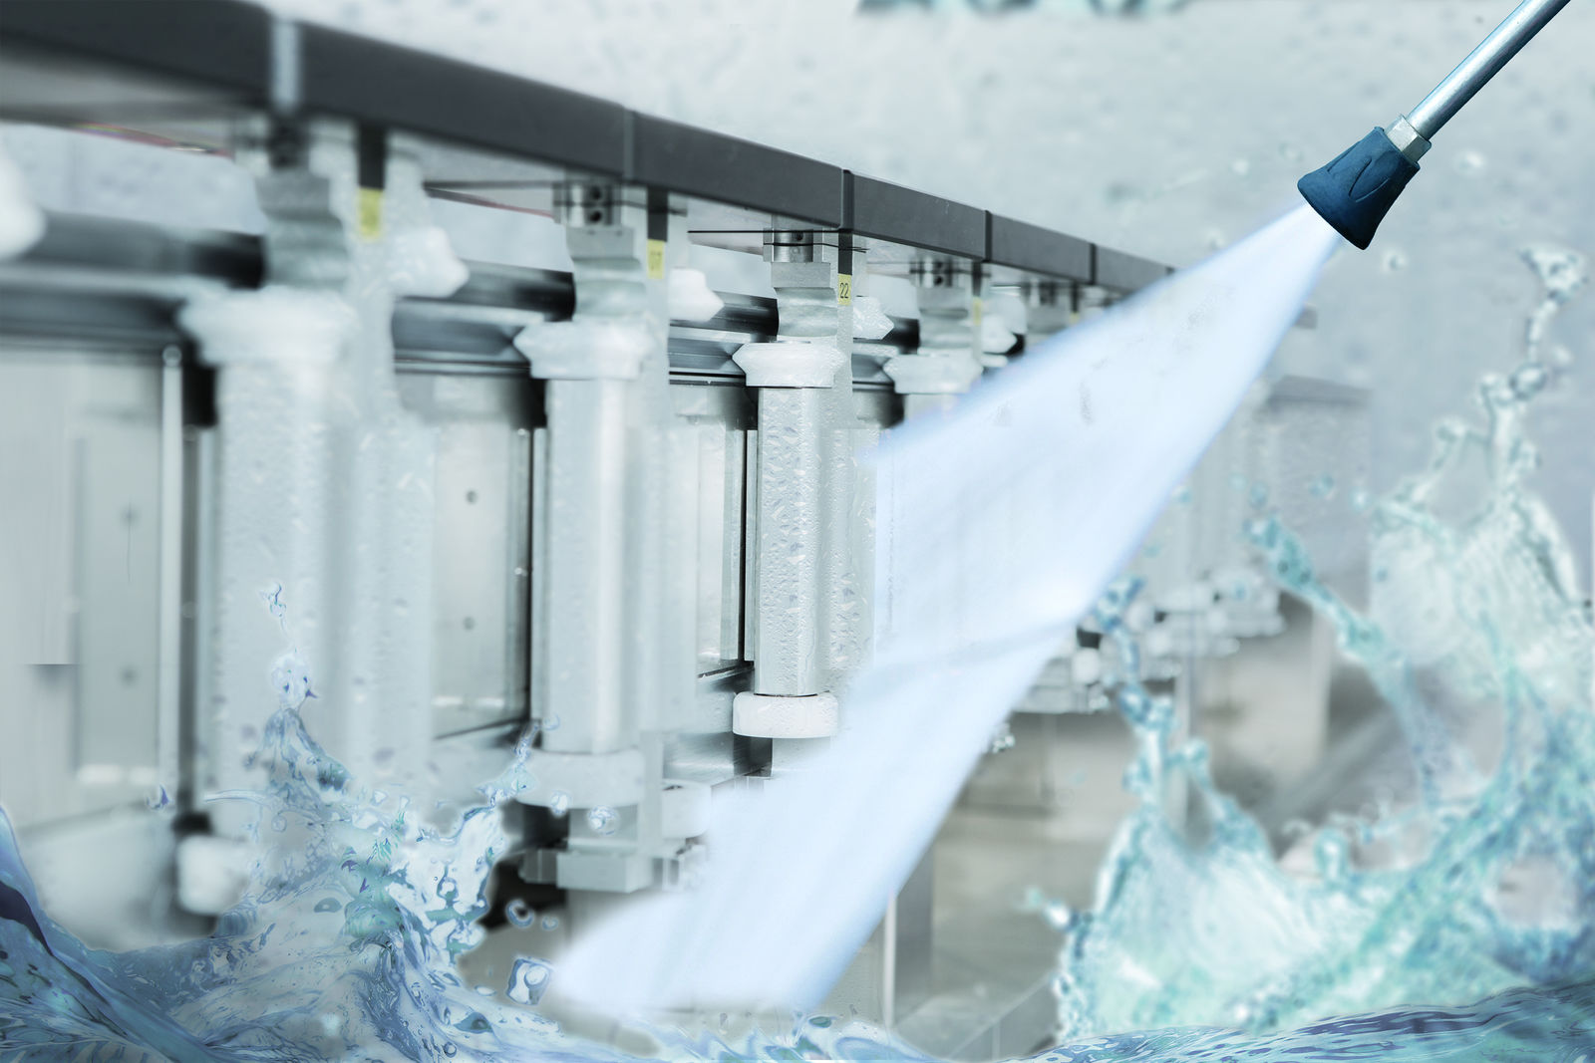
The new track is protected against high-pressure cleaning, and is also completely impervious to dust.

About B&R
B&R is an innovative automation company with headquarters in Austria and offices all around the world. On July 6, 2017, B&R became a business unit of the ABB Group. As a global leader in industrial automation, B&R combines state-of-the-art technology with advanced engineering to provide customers in virtually every industry with complete solutions for machine and factory automation, motion control, HMI and integrated safety technology. With Industrial IoT communication standards like OPC UA, POWERLINK and openSAFETY as well as the powerful Automation Studio software development environment, B&R is constantly redefining the future of automation engineering. The innovative spirit that keeps B&R at the forefront of industrial automation is driven by a commitment to simplifying processes and exceeding customer expectations.
For more information, visit www.br-automation.com.

