Mass production was yesterday
EMO: SuperTrak brings batch size one to the metal industry
The metal industry is not immune to the global trend away from bulk annual orders toward small-batch customer orders with short lead times. To handle this type of individualized production in batch sizes as small as one, manufacturing systems must become much more flexible. B&R's booth at EMO (Hall 9, Booth F50) will showcase track-based transport technology, whose independently controlled shuttles and rapid changeover times enable flexible, customer-centered manufacturing.
Track-based flexibility
Large annual bulk orders are giving way to smaller orders with shorter lead times and frequently changing requirements. Meeting these demands requires manufacturing systems that can adapt to these changes quickly and easily. AT EMO, B&R will showcase its SuperTrak transport system, which can be scaled easily in one-meter increments. The independently controlled shuttles give machine designers all the flexibility they need. A demo system featuring ABB robots highlights how seamlessly other subsystems can interact with the track system and perform additional production tasks.
Efficiency and profitability
Mass customization centers around an ability to produce small batches cost-effectively. Users of track technology benefit from high transport speeds and short changeover times that make manufacturing profitable down to batch size one.

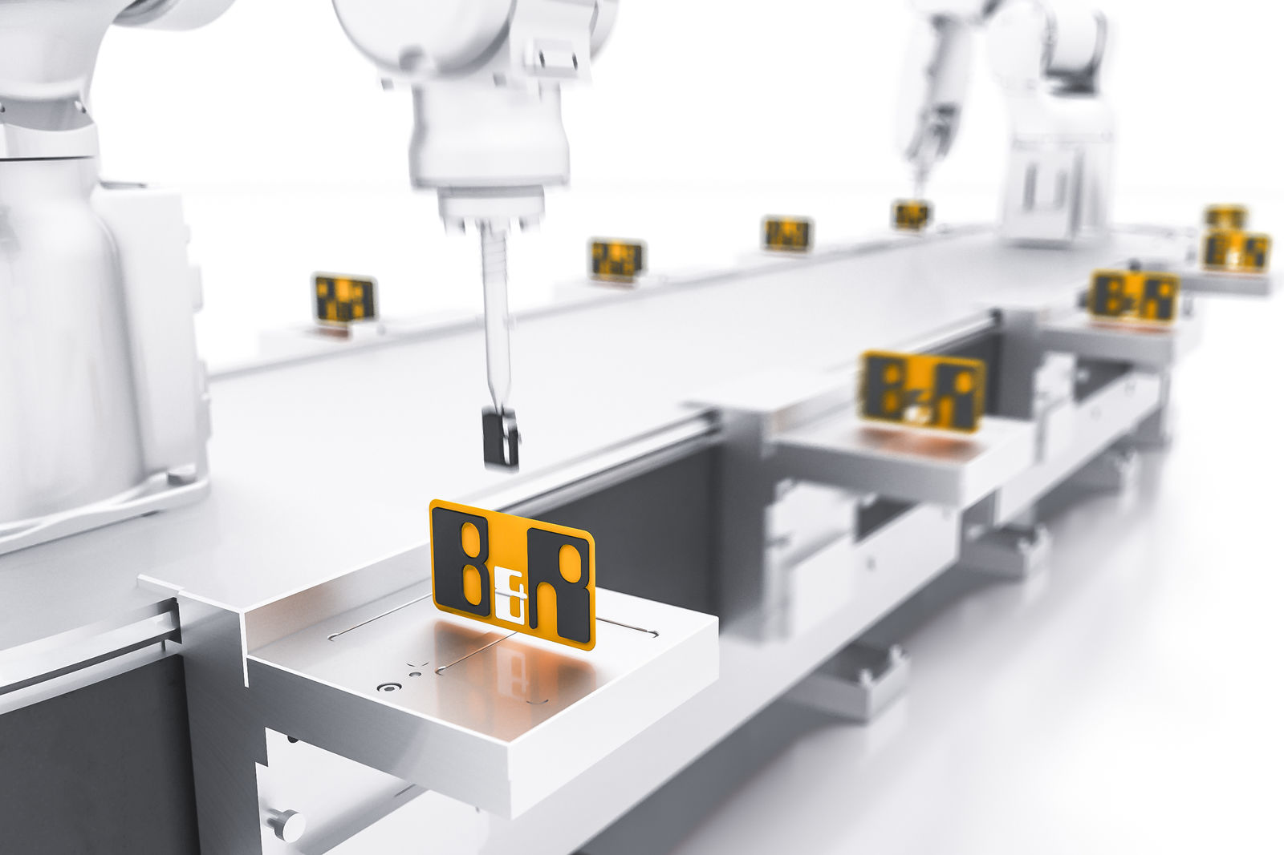
At EMO, B&R will show how SuperTrak enables flexible manufacturing and mass customization down to batch size one.

About B&R
B&R is an innovative automation company with headquarters in Austria and offices all around the world. On July 6, 2017, B&R became a business unit of the ABB Group. As a global leader in industrial automation, B&R combines state-of-the-art technology with advanced engineering to provide customers in virtually every industry with complete solutions for machine and factory automation, motion control, HMI and integrated safety technology. With Industrial IoT communication standards like OPC UA, POWERLINK and openSAFETY as well as the powerful Automation Studio software development environment, B&R is constantly redefining the future of automation engineering. The innovative spirit that keeps B&R at the forefront of industrial automation is driven by a commitment to simplifying processes and exceeding customer expectations.
For more information, visit www.br-automation.com.

