Compact and high-performance
New B&R compact controller with integrated switch
B&R's latest addition to its Compact-S series is a compact controller with an integrated switch. With an integrated switch, it enables daisy-chain cabling between network stations.

At a width of only 37.5 mm including the power supply, the X20CP0420 is extremely compact. The controller achieves cycle times down to 4 ms and is equipped with 128 MB RAM and 256 MB internal flash memory. With Ethernet, USB and RS232, the controller offers plenty of communication options. An optional CAN bus interface is also available. With no fans or batteries, the compact controller is also maintenance free.
Sleek automation solution
X20 I/O modules can be connected directly to the controller and line up seamlessly. The entire system saves a large amount of space in the control cabinet. Even with its narrow dimensions, the controller has a built-in power supply for itself and the connected I/O modules. There is no need for a separate power supply module.

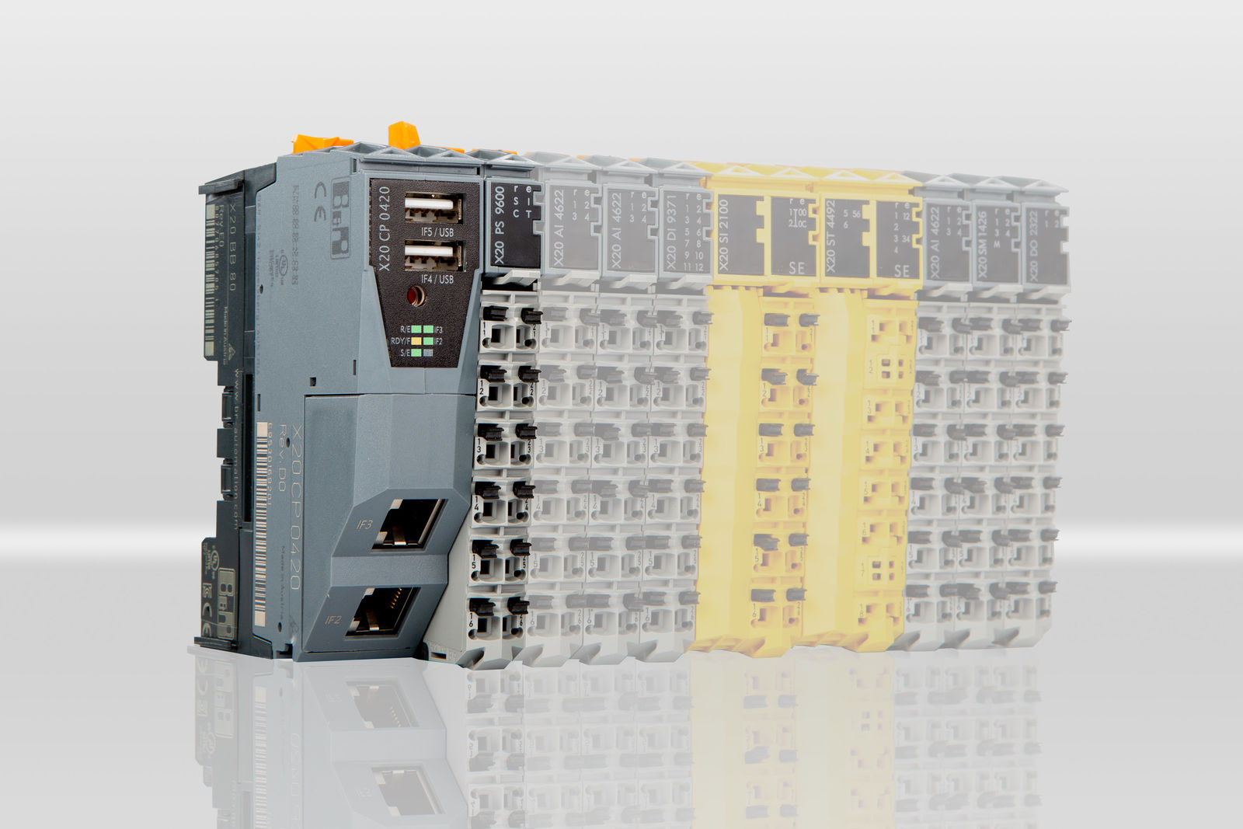
At a width of only 37.5 mm including the power supply, the X20CP0420 is extremely compact.

About B&R
B&R is an innovative automation company with headquarters in Austria and offices all around the world. On July 6, 2017, B&R became a business unit of the ABB Group. As a global leader in industrial automation, B&R combines state-of-the-art technology with advanced engineering to provide customers in virtually every industry with complete solutions for machine and factory automation, motion control, HMI and integrated safety technology. With Industrial IoT communication standards like OPC UA, POWERLINK and openSAFETY as well as the powerful Automation Studio software development environment, B&R is constantly redefining the future of automation engineering. The innovative spirit that keeps B&R at the forefront of industrial automation is driven by a commitment to simplifying processes and exceeding customer expectations.
For more information, visit www.br-automation.com.

