New possibilities with digital twins
B&R MapleSim Connector simplifies model-based machine development.
B&R simplifies model-based machine development with the new B&R MapleSim Connector. It considerably reduces the time spent modeling machine components. Machine functions are easy to program and deploy. B&R MapleSim Connector is seamlessly integrated in the B&R Automation Studio environment.

B&R MapleSim Connector makes it efficient for B&R customers to integrate the MapleSim tool from Maplesoft. MapleSim creates a highly accurate, dynamic model of the machine based on CAD data in STEP format. All forces and torques are modeled with great precision, allowing the model to be used as a digital twin for component sizing. The physical model is also available as a functional mock up unit for virtual commissioning of the machine software in Automation Studio. This helps avoid the risk of costly design errors.
Efficient use of digital twins
B&R MapleSim Connector offers two export functions for efficient use of digital twins in the development process. On the one hand, it is possible to export simulation data to optimize the sizing of servo drives, motors and gearboxes using tools like ServoSoft. Alternatively, the model built in MapleSim can be exported as an FMI file, including the CAD data.
Transfer models to hardware quickly
The model built in MapleSim can be used as a simulation model in Automation Studio and transferred directly to the B&R control hardware. The result is hardware-in-the-loop simulation, where the machine's behavior is emulated in real time to create a controlled environment where the machine software can be tested safely. In this environment, all control parameters can be manipulated and the temperature behavior of the drive can be simulated. The behavior of the digital twin is visualized live in B&R Scene Viewer.

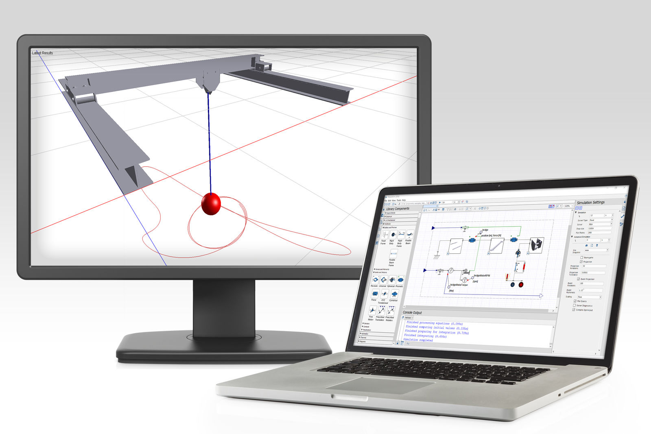
B&R MapleSim Connector creates a dynamic model of the machine in high detail based on CAD data in STEP format.

About B&R
B&R is an innovative automation company with headquarters in Austria and offices all around the world. On July 6, 2017, B&R became a business unit of the ABB Group. As a global leader in industrial automation, B&R combines state-of-the-art technology with advanced engineering to provide customers in virtually every industry with complete solutions for machine and factory automation, motion control, HMI and integrated safety technology. With Industrial IoT communication standards like OPC UA, POWERLINK and openSAFETY as well as the powerful Automation Studio software development environment, B&R is constantly redefining the future of automation engineering. The innovative spirit that keeps B&R at the forefront of industrial automation is driven by a commitment to simplifying processes and exceeding customer expectations.
For more information, visit www.br-automation.com.

