B&R safety module saves space in the control cabinet
New B&R module provides six safety relays on a unit with a width of only 25 mm
The new X20SO6530 digital output module provides six safety relays on a unit with the X20's standard 25 mm width, allowing B&R to offer a cost-effective and space-saving solution for applications where numerous floating signals are needed.

To meet safety requirements, positively driven feedback contacts must be evaluated in a manner that is appropriate for safety technology. This new X20 module evaluates this data internally, making it just as easy to use the six safe relay outputs as it is to use semiconductor-based outputs. The digital output module has single-channel isolated outputs with a maximum switching capacity of 230 VAC / 6 A or 24 VDC / 6 A.

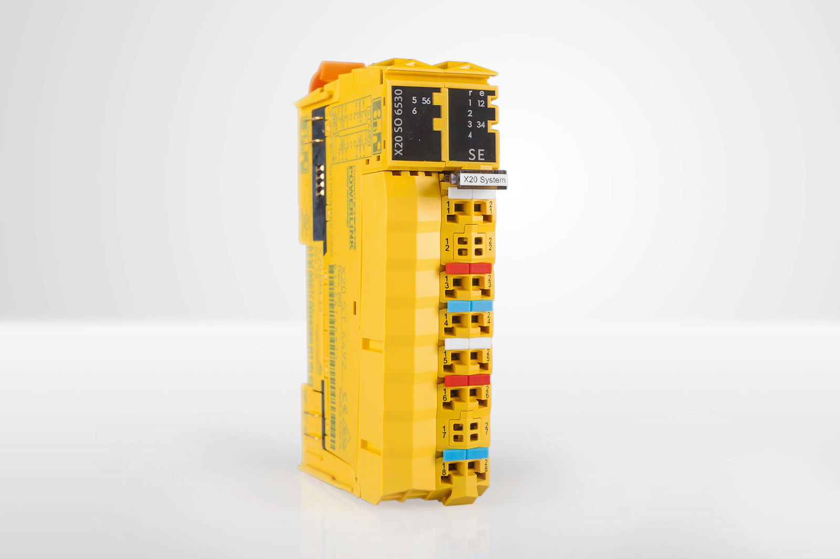
The new X20SO6530 digital output module provides six safety relays on a unit with a width of only 25 mm.

About B&R
B&R is an innovative automation company with headquarters in Austria and offices all around the world. On July 6, 2017, B&R became a business unit of the ABB Group. As a global leader in industrial automation, B&R combines state-of-the-art technology with advanced engineering to provide customers in virtually every industry with complete solutions for machine and factory automation, motion control, HMI and integrated safety technology. With Industrial IoT communication standards like OPC UA, POWERLINK and openSAFETY as well as the powerful Automation Studio software development environment, B&R is constantly redefining the future of automation engineering. The innovative spirit that keeps B&R at the forefront of industrial automation is driven by a commitment to simplifying processes and exceeding customer expectations.
For more information, visit www.br-automation.com.

