Save energy and increase performance
B&R introduces new stepper motor module from the X20 series
With the X20SM1436-1 module, B&R has added to its portfolio a new X20 module for direct control of stepper motors. The module can be used to operate stepper motors with operating voltages from 18 to 60 VDC at rated currents up to 2.5 A. In addition, the integrated current reduction function increases performance and reduces energy consumption.
With the current reduction function, B&R has integrated sensorless, load-dependent current control, which significantly increases the performance of the module. By regulating the current downwards depending on the operating situation and load, the module allows energy savings of up to 75 percent.
Smoother operation
The current reduction function also significantly reduces power dissipation and heat accumulation in the module. At the same time, current control also results in the stepper motor running more smoothly. For self-protection, the stepper motor module has an inrush current limiter and a motor outlet with short circuit and overload protection.
Digital inputs with open circuit monitoring
The module has four digital 24 VDC inputs. Three of them can be configured as ABR encoder inputs with a counter frequency of 50 kHz for 4x evaluation. In addition, all digital inputs have open circuit monitoring, which increases operational security. To detect slippage, the module has been equipped with stall detection.

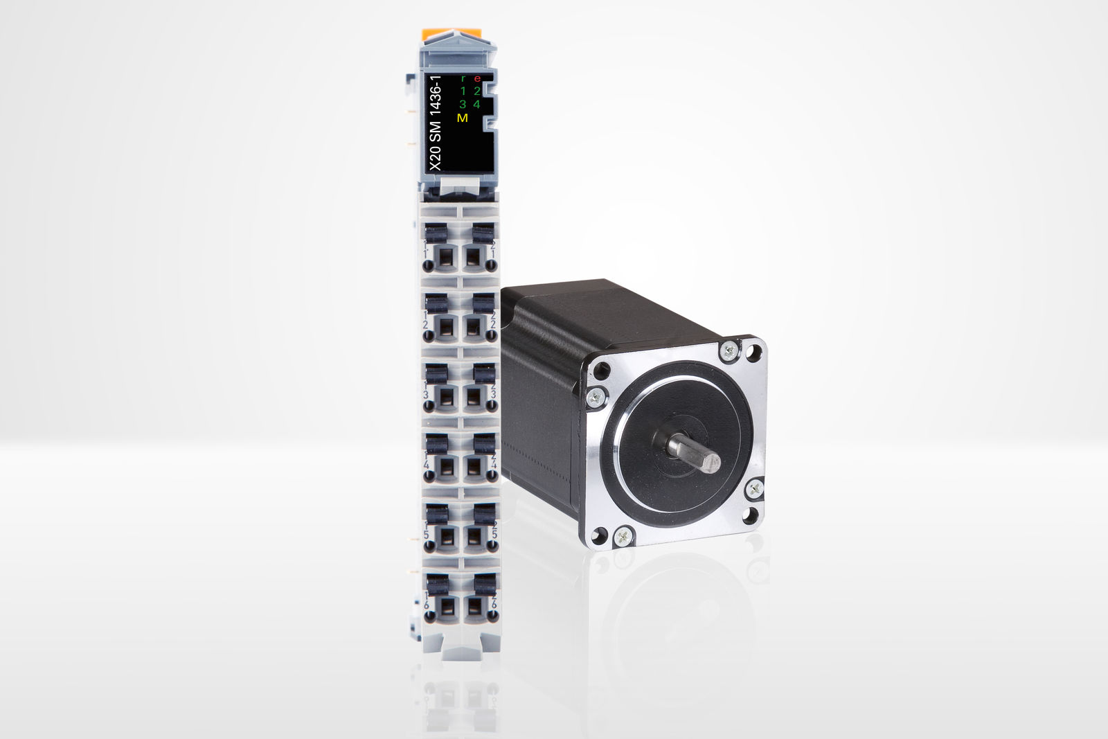
The new stepper motor module from the X20 series offers sensorless and load-dependent current control.

About B&R
B&R is an innovative automation company with headquarters in Austria and offices all around the world. On July 6, 2017, B&R became a business unit of the ABB Group. As a global leader in industrial automation, B&R combines state-of-the-art technology with advanced engineering to provide customers in virtually every industry with complete solutions for machine and factory automation, motion control, HMI and integrated safety technology. With Industrial IoT communication standards like OPC UA, POWERLINK and openSAFETY as well as the powerful Automation Studio software development environment, B&R is constantly redefining the future of automation engineering. The innovative spirit that keeps B&R at the forefront of industrial automation is driven by a commitment to simplifying processes and exceeding customer expectations.
For more information, visit www.br-automation.com.

