Greater efficiency, less wear
WindEnergy Hamburg: B&R servo drive technology optimizes yaw control
At WindEnergy Hamburg in Hall B6, Booth 242, B&R will show how wind turbines can be operated more efficiently, quietly and safely. B&R's intelligent motion control solutions based on its ACOPOS P3 servo drive enable more efficient motor utilization. By reducing the total number of motors – especially in larger turbines – operators save on both initial investment and ongoing maintenance costs.
Intelligent servo drive technology prevents yaw control from wearing out the brakes, which means the brake pads no longer need to be replaced. System availability goes up, maintenance costs go down and the noise generated by hardened brake pads is eliminated.
Increased safety with B&R controller
Safety technology must ensure that any workers inside the nacelle cannot be injured by the yaw system. The B&R control concept prevents safety mechanisms from being tampered with or disabled. This prevents accidents from occurring during commissioning and maintenance and makes the wind farm a much safer place to work.
Condition monitoring with Industrial IoT
At WindEnergy Hamburg, B&R will also demonstrate how wind farm operators can use condition monitoring to collect data about the health of their equipment. B&R edge devices process this data and transfer it to the cloud. The vendor-independent OPC UA protocol provides seamless, interface-free communication between the wind turbine and the cloud. The collected data allows turbine operators to do things like optimize maintenance intervals.

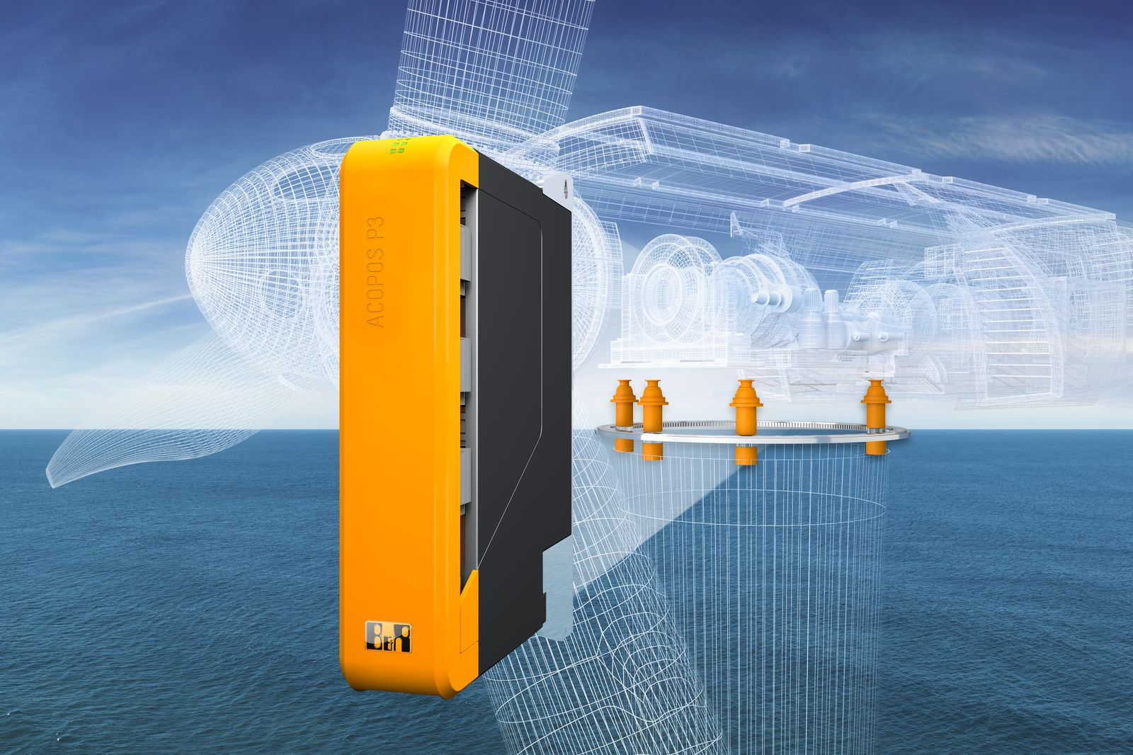
B&R servo drive technology makes yaw systems more efficient and less prone to wear.

About B&R
B&R is an innovative automation company with headquarters in Austria and offices all around the world. On July 6, 2017, B&R became a business unit of the ABB Group. As a global leader in industrial automation, B&R combines state-of-the-art technology with advanced engineering to provide customers in virtually every industry with complete solutions for machine and factory automation, motion control, HMI and integrated safety technology. With Industrial IoT communication standards like OPC UA, POWERLINK and openSAFETY as well as the powerful Automation Studio software development environment, B&R is constantly redefining the future of automation engineering. The innovative spirit that keeps B&R at the forefront of industrial automation is driven by a commitment to simplifying processes and exceeding customer expectations.
For more information, visit www.br-automation.com.

