Unmatched efficiency with high-speed diverters
B&R presents flexible transport system at Hannover Messe
B&R's new flexible transport system is designed to deliver ultimate production effectiveness – from mass production down to batches of one. Playing a pivotal role in making this possible are the system's purely electromagnetic diverters, which are able to divide and merge product flows at full production speed. B&R will be presenting its transport system from April 23-27 at the Hannover Messe in Hall 9, Booth D26.
Seamless connectivity
The B&R booth will also showcase how OPC UA TSN makes it possible to implement advanced manufacturing concepts with seamless connectivity from the field level up to ERP systems. Another Industrial IoT highlight will be B&R's Orange Box solution. This custom hardware/software package makes it easy to tap into the data of digitally isolated brownfield equipment so it can be utilized by higher-level systems.
Industrial PC premiere
B&R will be presenting a new generation of compact industrial PCs for the first time at the 2018 Hannover Messe. The PCs offer high performance and an extended array of options for connecting display units.

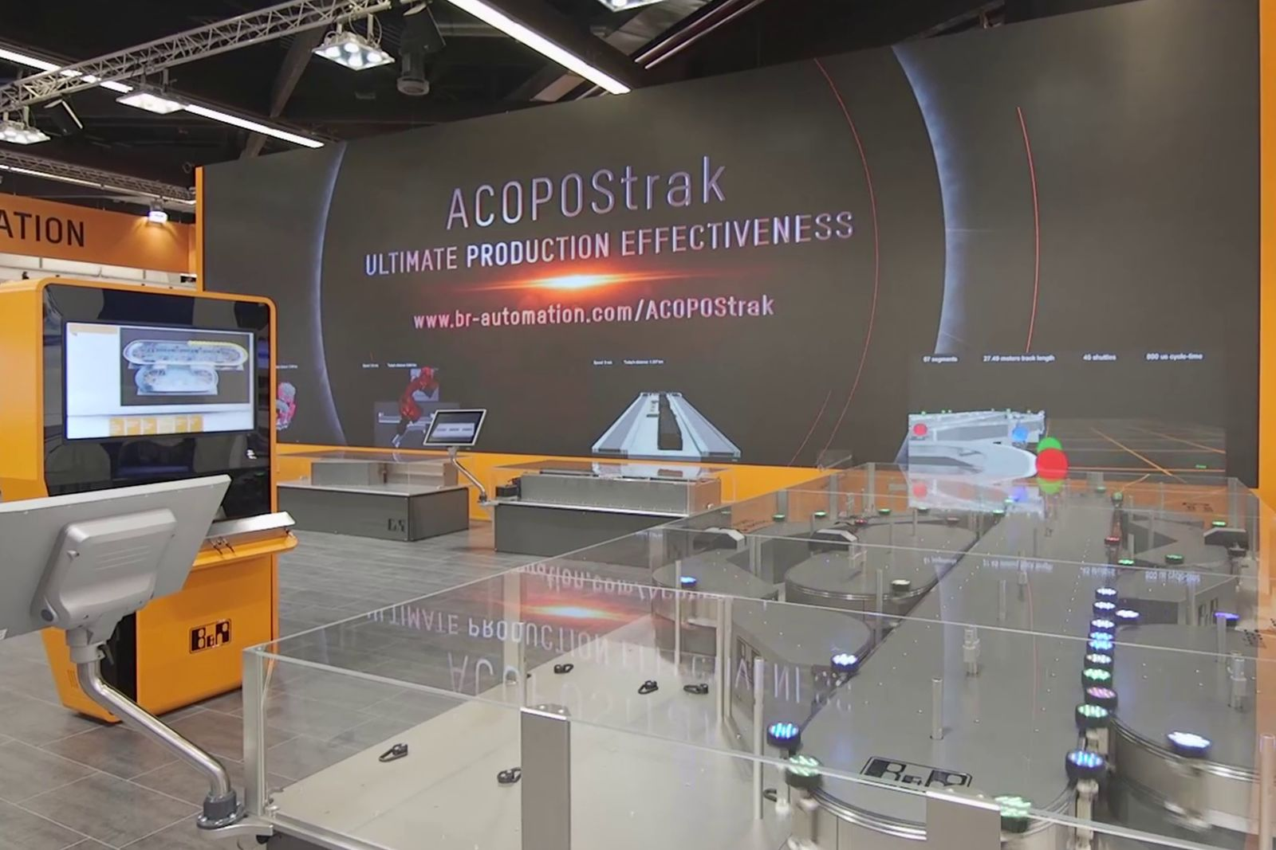
B&R will be showing how the high-speed diverters of its flexible ACOPOStrak transport system can significantly increase the effectiveness of production lines at the Hannover Messe in Hall 9, Booth D26.

About B&R
B&R is an innovative automation company with headquarters in Austria and offices all around the world. On July 6, 2017, B&R became a business unit of the ABB Group. As a global leader in industrial automation, B&R combines state-of-the-art technology with advanced engineering to provide customers in virtually every industry with complete solutions for machine and factory automation, motion control, HMI and integrated safety technology. With Industrial IoT communication standards like OPC UA, POWERLINK and openSAFETY as well as the powerful Automation Studio software development environment, B&R is constantly redefining the future of automation engineering. The innovative spirit that keeps B&R at the forefront of industrial automation is driven by a commitment to simplifying processes and exceeding customer expectations.
For more information, visit www.br-automation.com.

