Keep track of vibrations and environmental conditions
B&R presents new I/O modules for monitoring control cabinets.
With three new I/O modules in its X20 series, B&R makes control cabinet monitoring easier than ever. All three modules measure temperature and humidity in the control cabinet and log how much time the values spend within defined ranges. Critical environment conditions can therefore also be evaluated at a later time. The modules also log operating hours and power cycles internally.
Save recipes permanently
The X20CMR010 and X20CMR111 are also equipped with 512 kB of non-volatile user memory. The memory functions without a battery and is therefore maintenance free. It can be used to store recipes and other data. The data will remain in the system even if the controller needs to be replaced.
Integrated Technology Guarding
Two of the new I/O modules provide Technology Guarding functionality and can be used to manage software licenses. This is especially helpful if there is no USB port available for dongles or if the port can't be used due to security concerns.

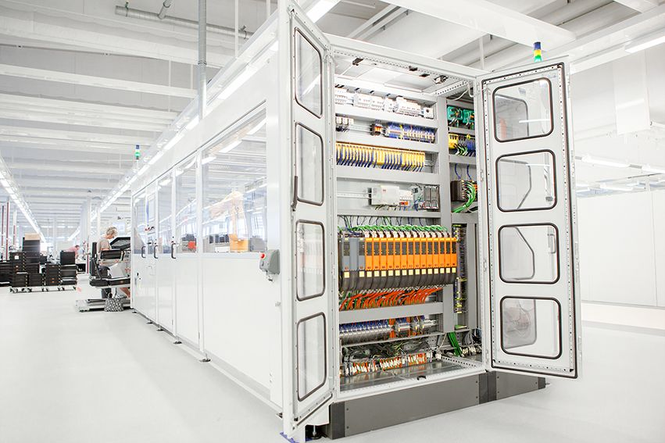
The new I/O modules measure the temperature and humidity in the control cabinet and log much time the values spend within defined ranges.

About B&R
B&R is an innovative automation company with headquarters in Austria and offices all around the world. On July 6, 2017, B&R became a business unit of the ABB Group. As a global leader in industrial automation, B&R combines state-of-the-art technology with advanced engineering to provide customers in virtually every industry with complete solutions for machine and factory automation, motion control, HMI and integrated safety technology. With Industrial IoT communication standards like OPC UA, POWERLINK and openSAFETY as well as the powerful Automation Studio software development environment, B&R is constantly redefining the future of automation engineering. The innovative spirit that keeps B&R at the forefront of industrial automation is driven by a commitment to simplifying processes and exceeding customer expectations.
For more information, visit www.br-automation.com.

