Advanced automation platform for mobile equipment
B&R presents condition monitoring solution at Agritechnica
At this year's Agritechnica exhibition from November 12-18 in Hanover, B&R will be presenting a condition monitoring solution for mobile automation. Visitors to Hall 15, Booth H13 will also see how advanced automation solutions can be implemented based on a comprehensive hardware portfolio, ready-made software components and a powerful engineering tool.
Predictive maintenance
The X90 controller with integrated condition monitoring allows operators of agricultural machinery to continuously monitor the health of their equipment. The results help determine exactly which components require maintenance and when. Problems can be detected in their early stages and corrected before they result in unplanned downtime. Repairs can instead be timed to coincide with regularly scheduled service.
Develop 3 times faster
The ready-made software components of mapp Technology make it easier and faster to perform frequently recurring programming tasks. With the software for new machinery and equipment completed in a third of the time, this brings a dramatic reduction in time to market. Since the components are maintained entirely by B&R, the resulting application software is also of higher quality.

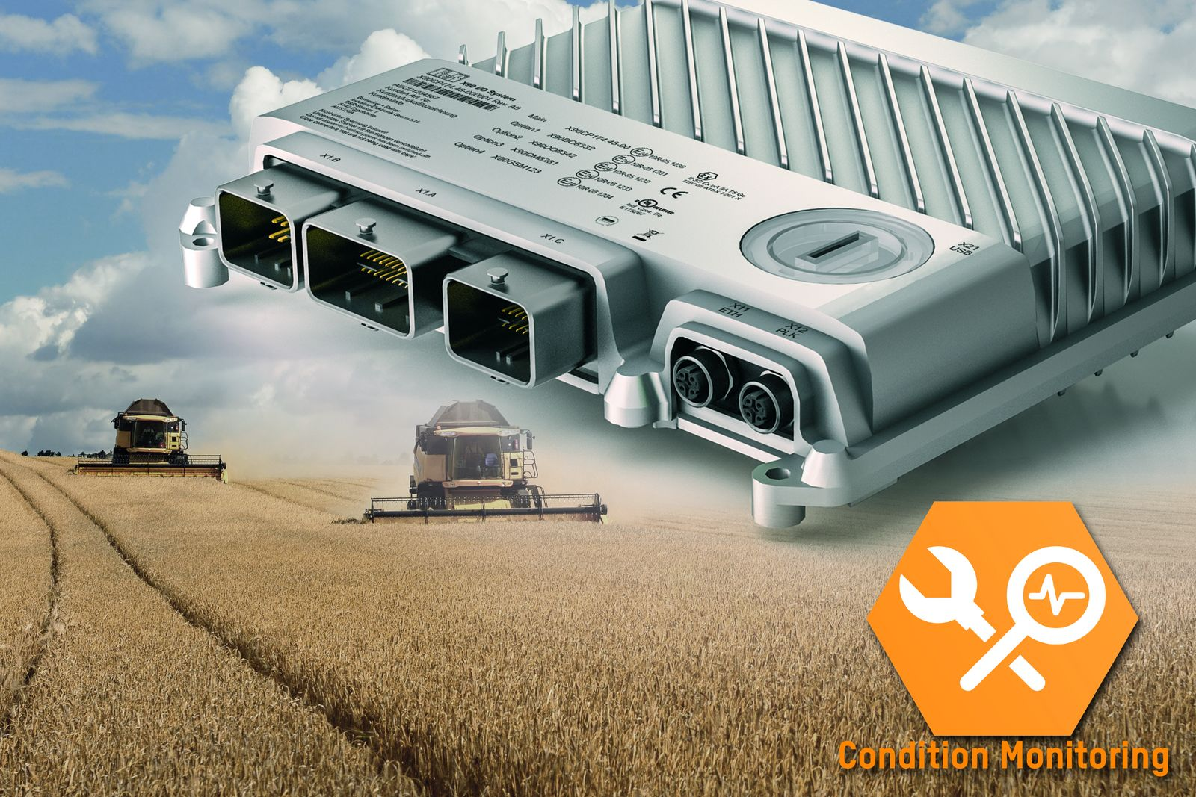
At Agritechnica, B&R presents a condition monitoring solution for mobile applications. The X90 controller with integrated condition monitoring allows operators of agricultural machinery to continuously monitor the health of their equipment.

About B&R
B&R is an innovative automation company with headquarters in Austria and offices all around the world. On July 6, 2017, B&R became a business unit of the ABB Group. As a global leader in industrial automation, B&R combines state-of-the-art technology with advanced engineering to provide customers in virtually every industry with complete solutions for machine and factory automation, motion control, HMI and integrated safety technology. With Industrial IoT communication standards like OPC UA, POWERLINK and openSAFETY as well as the powerful Automation Studio software development environment, B&R is constantly redefining the future of automation engineering. The innovative spirit that keeps B&R at the forefront of industrial automation is driven by a commitment to simplifying processes and exceeding customer expectations.
For more information, visit www.br-automation.com.

