Two operating systems on one device
B&R is introducing a hypervisor for its automation system
B&R is introducing a hypervisor for its automation system. This software allows Windows or Linux to run alongside B&R's own real-time operating system. This makes it possible to combine a controller and HMI PC in one device. With the hypervisor, an industrial PC can also be used as an edge controller. This serves as a controller and simultaneously transmits pre-processed data to higher-level systems in the cloud via OPC UA.
Virtual network
The hypervisor provides a virtual network connection that allows applications to exchange data between operating systems. Like with the usual Ethernet interface, this is done using standard network protocols. In place of a cable, there is a reserved memory area that is not assigned to either operating system.
Maximum flexibility
The user configures the hypervisor and allocates hardware resources in the B&R Automation Studio software development environment. The configurations are defined separately for each system, providing maximum flexibility in how resources are utilized. Whereas previous parallelization solutions were tailored to a specific Windows version, B&R's hypervisor is completely independent of which operating systems are used.

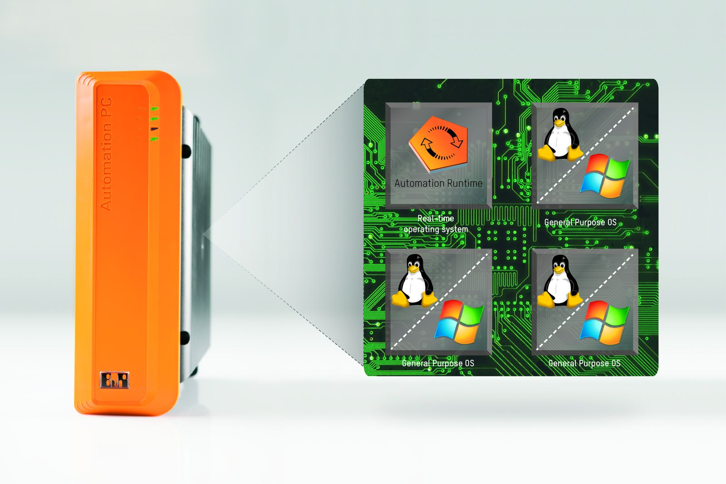
B&R Hypervisor allows multiple operating systems to run in parallel on a single device. The operating systems can communicate with each other via a virtual network.

About B&R
B&R is an innovative automation company with headquarters in Austria and offices all around the world. On July 6, 2017, B&R became a business unit of the ABB Group. As a global leader in industrial automation, B&R combines state-of-the-art technology with advanced engineering to provide customers in virtually every industry with complete solutions for machine and factory automation, motion control, HMI and integrated safety technology. With Industrial IoT communication standards like OPC UA, POWERLINK and openSAFETY as well as the powerful Automation Studio software development environment, B&R is constantly redefining the future of automation engineering. The innovative spirit that keeps B&R at the forefront of industrial automation is driven by a commitment to simplifying processes and exceeding customer expectations.
For more information, visit www.br-automation.com.

