From simulation to operation with a click of the mouse
Optimized engineering with 3D SuperTrak simulation
A new visualization tool from B&R accelerates development of automation solutions featuring its SuperTrak industrial transport system. The tool displays a 3D simulation of all SuperTrak shuttle movements, as well as synchronized subsystems such as robotics and CNC. Machine builders and operators can accelerate the commissioning process by validating their designs and sequential programming in advance.
3D simulation with machine code
The visualization tool and extensive simulation options are fully integrated in B&R's Automation Studio software development environment. All simulations are based on real machine code and no additional simulation software or interfaces are required.
In simulation mode, a 3D visualization in the development environment allows processes to be fine-tuned prior to commissioning. With a few clicks of the mouse, the optimized machine code is then transferred to the target hardware.
At runtime, the visualization tool processes sensor signals to display machine movements on the HMI screen in real time. 3D visualization is the perfect way to monitor your manufacturing processes.

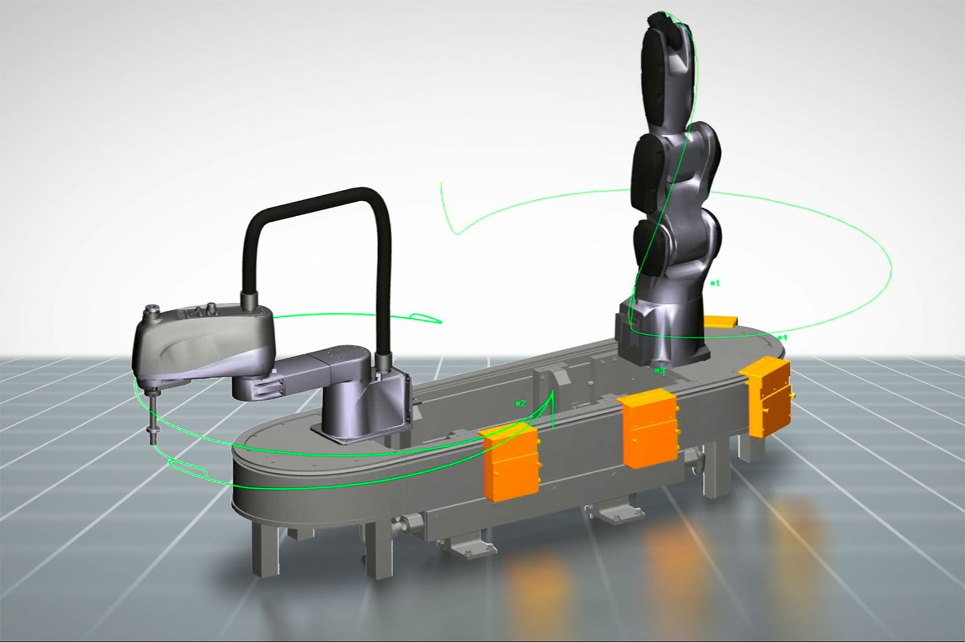
3D simulation shows the behavior of all shuttles in combination with synchronized subsystems like robotics and CNC.

About B&R
B&R is an innovative automation company with headquarters in Austria and offices all around the world. On July 6, 2017, B&R became a business unit of the ABB Group. As a global leader in industrial automation, B&R combines state-of-the-art technology with advanced engineering to provide customers in virtually every industry with complete solutions for machine and factory automation, motion control, HMI and integrated safety technology. With Industrial IoT communication standards like OPC UA, POWERLINK and openSAFETY as well as the powerful Automation Studio software development environment, B&R is constantly redefining the future of automation engineering. The innovative spirit that keeps B&R at the forefront of industrial automation is driven by a commitment to simplifying processes and exceeding customer expectations.
For more information, visit www.br-automation.com.

