Industrial IoT for brownfields
B&R's Orange Box is the smart-factory upgrade for legacy equipment
At the 2017 Hannover Messe, B&R presents its new Orange Box solution. The Orange Box enables machine operators to collect and analyze data from previously isolated machines and lines and get them fit for the smart factory with a minimal effort.
An Orange Box consists of a controller and B&R mapp Technology's preconfigured software blocks – known as mapps. The controller collects operating data from any machine via its I/O channels or a fieldbus connection. From this data, the mapps generate and display OEE ratings and other KPIs, and can also share the information with higher-level systems via OPC UA.
Simple as a smartphone
Installing the Orange Box requires no changes to existing hardware or software. Equipment owners can achieve a substantial boost in productivity with a remarkably small investment in time and cost. Thanks to the mapps, the Orange Box is as simple and intuitive to operate as a smartphone.
Perfectly fitted for every need
The Orange Box is entirely flexible and modular. To collect and analyze basic operating data, all you need is a 25-millimeter-wide compact PLC and the mapp OEE component. For more advanced features – such as alarm management or energy monitoring – the solution can easily be scaled up with more powerful PLCs and additional software components. To give the Orange Box a modern user interface in addition to PLC functionality, a Power Panel or a Panel PC can be used.

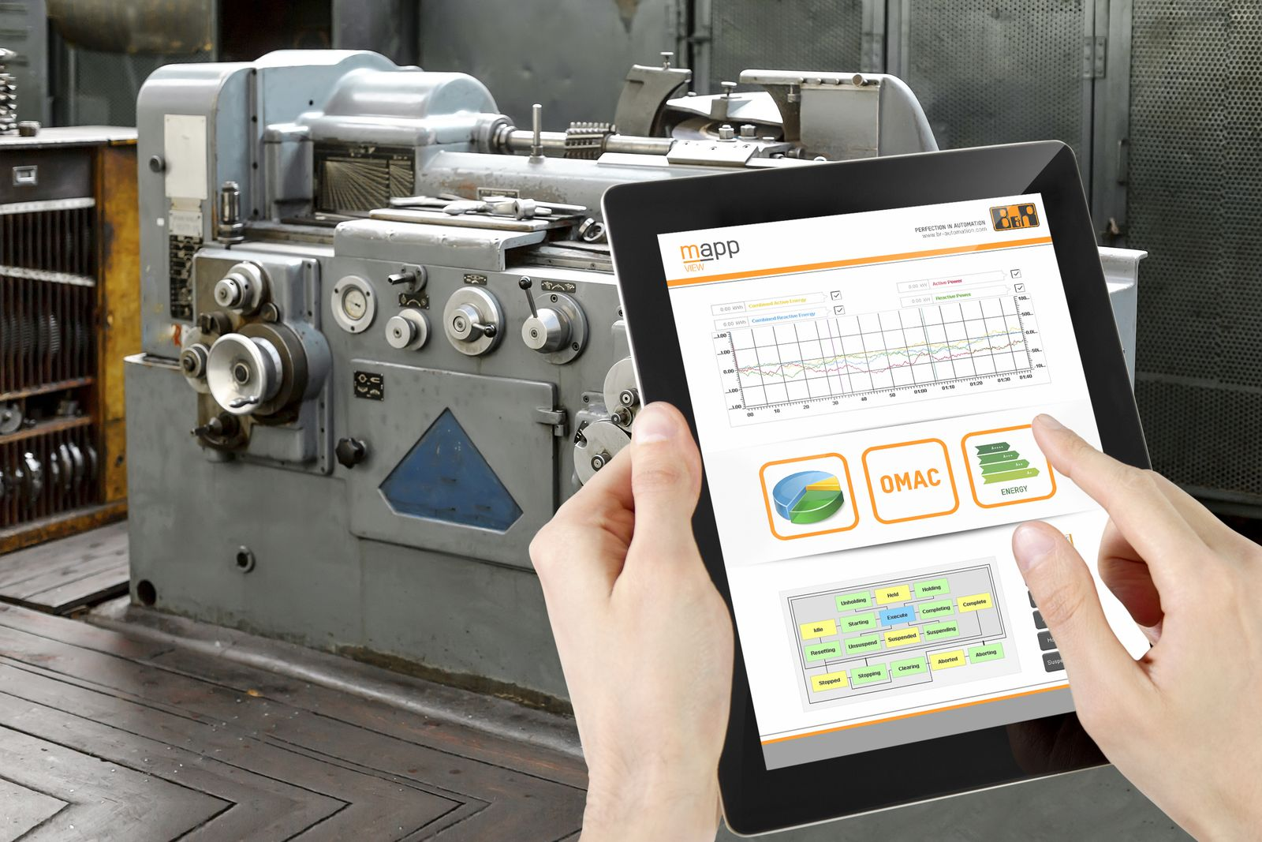
B&R's Orange Box enables machine operators to collect and analyze data from previously isolated machines and lines and get them fit for the smart factory.

About B&R
B&R is an innovative automation company with headquarters in Austria and offices all around the world. On July 6, 2017, B&R became a business unit of the ABB Group. As a global leader in industrial automation, B&R combines state-of-the-art technology with advanced engineering to provide customers in virtually every industry with complete solutions for machine and factory automation, motion control, HMI and integrated safety technology. With Industrial IoT communication standards like OPC UA, POWERLINK and openSAFETY as well as the powerful Automation Studio software development environment, B&R is constantly redefining the future of automation engineering. The innovative spirit that keeps B&R at the forefront of industrial automation is driven by a commitment to simplifying processes and exceeding customer expectations.
For more information, visit www.br-automation.com.

