Reliable computing for food processing plants
The B&R panel PCs are available in various sizes and resolutions, with screens ranging from 12” to 24” with various processor options, as well as with a number of Ethernet, USB and VGA ports to allow easy connection of external interfaces and monitors.
Each model comes in a sturdy enclosure and is designed to withstand the high levels of vibration typically associated with production environments. Plant operators can also easily wash down the units to remove common contaminants typically present in industrial food processing plants, such as dust and liquid as well as food particles. The panel PCs ingress protection begins with IP65 for the aluminium enclosed product and continues up to a fully-hygienic stainless steel, splinter proof IP69K variant.
There is a choice between analogue resistive (single-touch) or projected capacitive (multi-touch) touchscreen, allowing for plant managers and engineers to easily interact with the device.
“Traceability is a big issue in the food processing industry and it has become increasingly important in recent years that businesses provide this at every stage,” explained Adrian Swindells, a director of Distec. “Plant managers need to be able to keep tabs on ingredients for every stage of production, particularly in the meat processing sector to comply with regulations such as EU 178/2002. This is why it is essential that a sturdy and reliable industrial PC is used so that businesses can ensure that all produce is monitored in real-time and accounted for without fear of unexpected failure or inoperability.“In fact, industrial PCs play a key role in managing plant processes at every stage of food production, whether it is a manufacturing or packaging plant. It is important that the PC itself is capable of functioning effectively under extreme conditions, such as the vibration of packaging equipment or the steam produced during processing.
“The B&R industrial PCs that we stock are designed to ensure optimum performance under these conditions and to guarantee reliable monitoring of ingredients and factory processes. Beyond the enclosure, the processing power of the PCs makes them capable of delivering consistent performance even with a high volume of input sources, while the number of ports makes them easy for engineers to integrate into existing systems.”
“We at B&R are pleased with partnering with Distec due to their strong presence and reputation in the market as well as their potential for growth. We believe our proven industrial panel PC products will not only add value for their customers due their reliability but also modernise the look of their production environment with the chic & sophisticated design,” states Alan Conn, Managing Director of B&R UK&I.
Further information about the B&R industrial PCs stocked by Distec, including tech sheets, can be found on the company website. Plant managers wishing to discuss the best industrial computing solution for their application can also consult with Distec on 01617 774 273.
Industrial computing specialist, Distec Ltd., now promoting rugged and reliable panel PCs by B&R Industrial Automation
Industrial computing specialist Distec Ltd is expanding its range of industrial PCs for food manufacturing and meat processing plants with the addition of B&R Industrial’s panel PCs. The company will be promoting B&R’s rugged and reliable panel PCs produced and designed in Austria. The range of products include panel PCs housed in a choice of aluminium or stainless-steel to provide the necessary protection for a variety of food processing plant environments whilst providing an elegant and clean finish to the design.

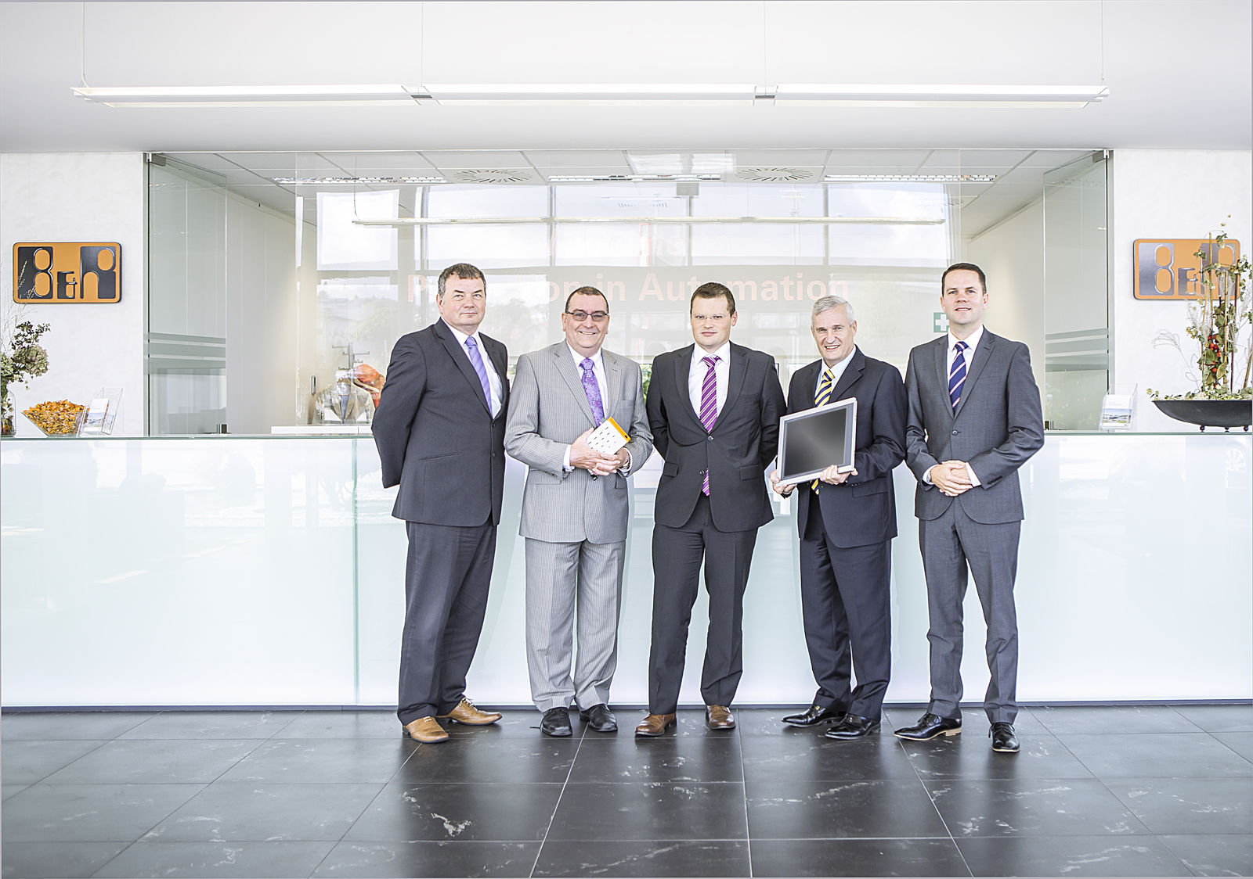
Distec Ltd. visiting B&R HQ in Eggelsberg, Austria.

About B&R
B&R is an innovative automation company with headquarters in Austria and offices all around the world. On July 6, 2017, B&R became a business unit of the ABB Group. As a global leader in industrial automation, B&R combines state-of-the-art technology with advanced engineering to provide customers in virtually every industry with complete solutions for machine and factory automation, motion control, HMI and integrated safety technology. With Industrial IoT communication standards like OPC UA, POWERLINK and openSAFETY as well as the powerful Automation Studio software development environment, B&R is constantly redefining the future of automation engineering. The innovative spirit that keeps B&R at the forefront of industrial automation is driven by a commitment to simplifying processes and exceeding customer expectations.
For more information, visit www.br-automation.com.

