More cost-effective stamping and forming
Servo-controlled RM-NC stamping and forming machines from Bihler are equipped with B&R automation technology.
Bihler will be presenting its new RM-NC stamping and forming machine at EuroBLECH 2016 at Booth E104 in Hall 27. The machine allows users to produce stamped and formed parts from strip and wire material more productively and cost-effectively than ever. To automate its innovative machines, Bihler relies on cutting-edge B&R technology.
With an output of up to 300 parts per minute, extremely fast setup and changeover times, and consistently high quality – the servo-controlled RM-NC offers decisive advantages. These are made possible by the combination of state-of-the-art servo technology from B&R and Bihler's intuitive VariControl control platform.
High-performance automation technology
Bihler uses B&R's compact, high-performance ACOPOSmulti servo drive system to control the NC axes, linear motors and main drive of the RM-NC. For the different variants of its machine, Bihler takes advantage of the ACOPOSmulti's flexible mounting options – either directly on the control cabinet wall or on a cold plate that can be connected to a water or oil cooling circuit.
Rapid response to customer requests
The new Bihler machine offers fully automated alignment and radial or linear positioning of the slide units at the push of a button. Once the easily mounted tool is in place, it's simply a matter of applying the preset parameters in the controller and the machine is ready to start creating usable parts with 100% reproducibility. This enables users to respond quickly to customer requests at any batch size.
State-of-the-art operator panels
RM-NC machines are operated using B&R Automation Panels. Brilliant high-definition graphics on edge-to-edge anti-glare touch screens offer the absolute latest in operator panel technology. The HMI application for the new Bihler machine runs on a powerful Automation PC 910. B&R's industrial PCs are built for continuous operation over a long service life in harsh industrial environments.

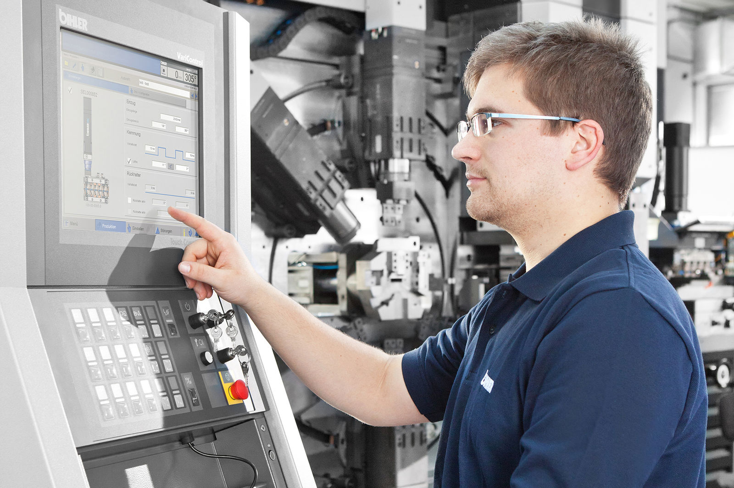
In its servo-controlled RM-NC stamping and forming machines, Bihler uses automation solutions from B&R to offer unprecedented productivity and cost-efficiency. (Source: Bihler)

About B&R
B&R is an innovative automation company with headquarters in Austria and offices all around the world. On July 6, 2017, B&R became a business unit of the ABB Group. As a global leader in industrial automation, B&R combines state-of-the-art technology with advanced engineering to provide customers in virtually every industry with complete solutions for machine and factory automation, motion control, HMI and integrated safety technology. With Industrial IoT communication standards like OPC UA, POWERLINK and openSAFETY as well as the powerful Automation Studio software development environment, B&R is constantly redefining the future of automation engineering. The innovative spirit that keeps B&R at the forefront of industrial automation is driven by a commitment to simplifying processes and exceeding customer expectations.
For more information, visit www.br-automation.com.

