Unique position even without a battery
B&R compact servo motors with new multi-turn encoder
B&R's 8LV compact servo motors in sizes 2 and 3 are now available with an optional multi-turn encoder without battery backup. The multi-turn position is retained even if the connection between the drive and motor is interrupted. This option removes the need for a buffer battery in the servo drive.
Safety encoders
The new inductive digital EnDat 2.2 encoders offer a wide variety of safety functions. These encoders also guarantee a very high level of control accuracy and are resistant to disturbances.
Compact design
Motors in the 8LV series are available with a 40, 60 or 80 mm flange and cover a power range of 0.1 to 1.3 kW. Their compact dimensions make them the perfect choice for tight enclosures. These motors also have a direct gearbox mounting option.

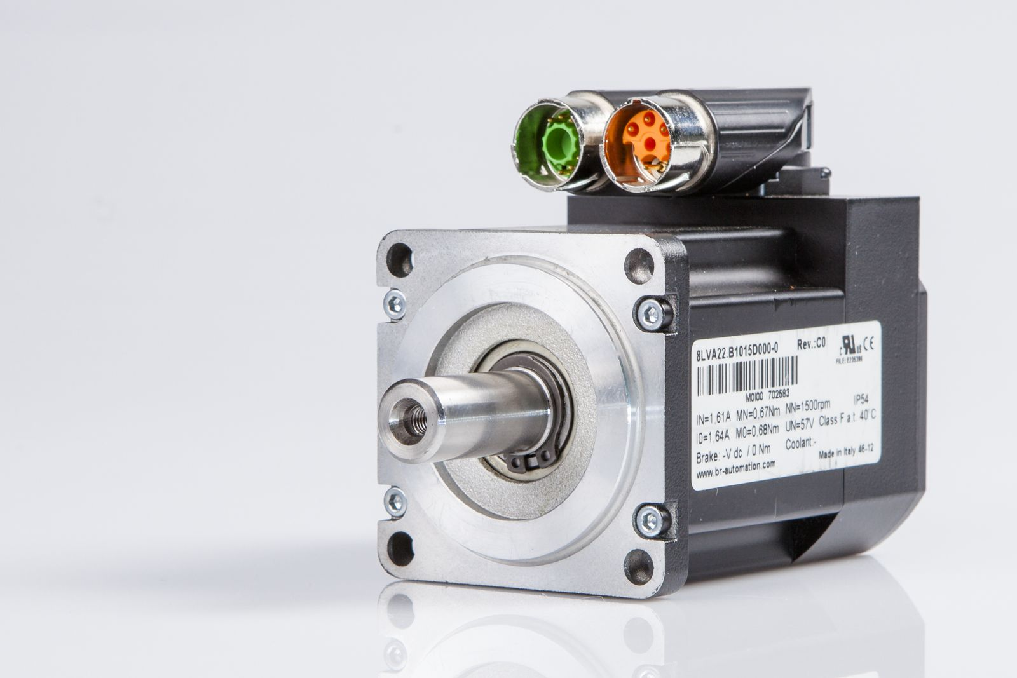
Their compact dimensions make B&R's compact servo motors the perfect choice for tight enclosures.

About B&R
B&R is an innovative automation company with headquarters in Austria and offices all around the world. On July 6, 2017, B&R became a business unit of the ABB Group. As a global leader in industrial automation, B&R combines state-of-the-art technology with advanced engineering to provide customers in virtually every industry with complete solutions for machine and factory automation, motion control, HMI and integrated safety technology. With Industrial IoT communication standards like OPC UA, POWERLINK and openSAFETY as well as the powerful Automation Studio software development environment, B&R is constantly redefining the future of automation engineering. The innovative spirit that keeps B&R at the forefront of industrial automation is driven by a commitment to simplifying processes and exceeding customer expectations.
For more information, visit www.br-automation.com.

