B&R joins Industrial Internet Consortium
More information on the IIC, Industry 4.0 and IoT can be found in this interview with Tony Shakib of Cisco and Stefan Schönegger and Marc Ostertag of B&R.
Actively shaping the future of industry
At the Hannover Messe, B&R announced its membership in the Industrial Internet Consortium (IIC). "B&R and the IIC share a common goal. We want to create an industrial environment where intelligent devices, machines, processes and data are all networked together," explained Marketing Manager Stefan Schönegger. "Together with the IIC's founding members – Cisco, GE, IBM and Intel – as well as its other member companies, we aim to play an active role in moving concepts based on the Internet of Things (IoT) rapidly from theory to full-scale production."
According to the IIC, this industrial future must be built on a common architecture, open standards and systems that are able to interact seamlessly. "The boundaries between Internet and automation technologies will continue to dissolve in the years to come," continued Schönegger. "We've been following this approach in our own production facilities for some time now, and we're happy to contribute our experience to the IIC's working groups."
Participation in TSN testbed
B&R's involvement includes participation in the IIC's "Time Sensitive Networking (TSN) Testbed", where the combination of TSN and OPC UA is being tested for the first time in an industrial environment. TSN is an extension of the IEEE 802.1 Ethernet standard that aims to give OPC UA real-time capability that opens up interface-free communication from the sensor layer to the ERP layer.

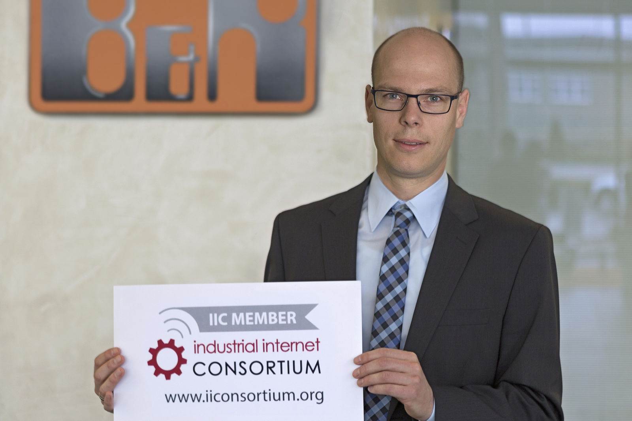
"B&R and the IIC share the common goal of moving concepts based on the Internet of Things (IoT) rapidly from theory to full-scale production," said Marketing Manager Stefan Schönegger of B&R's decision to join the Industrial Internet Consortium.

About B&R
B&R is an innovative automation company with headquarters in Austria and offices all around the world. On July 6, 2017, B&R became a business unit of the ABB Group. As a global leader in industrial automation, B&R combines state-of-the-art technology with advanced engineering to provide customers in virtually every industry with complete solutions for machine and factory automation, motion control, HMI and integrated safety technology. With Industrial IoT communication standards like OPC UA, POWERLINK and openSAFETY as well as the powerful Automation Studio software development environment, B&R is constantly redefining the future of automation engineering. The innovative spirit that keeps B&R at the forefront of industrial automation is driven by a commitment to simplifying processes and exceeding customer expectations.
For more information, visit www.br-automation.com.

