Mastering options in machine software with mapp CodeBox
Program variants in ladder logic with modular software components
OEMs now have a much easier way of managing the many variants of their machines. With mapp CodeBox, they can program options in ladder logic without affecting the machine's primary application.
OEMs still use the development environment to program their machines' basic functionality. In the process, they can define which data, functions and variables are to be accessed via mapp CodeBox. This allows the machines' special features and options to be added later using Ladder Diagram.
Easy options management
Having the software for individual options decoupled from the primary application offers numerous advantages. For one thing, it ensures that you're not introducing errors into the system when you implement new options or customizations. It also greatly simplifies the task of managing all the different variants of your machine.
HTML5 application
mapp CodeBox is an HTML5 application that can run on any browser-enabled device. A powerflow visualization provides support for diagnostics and maintenance. Ladder programs can be saved, subjected to version control and transferred to other machines. If necessary, they can also be imported back into the original automation project.

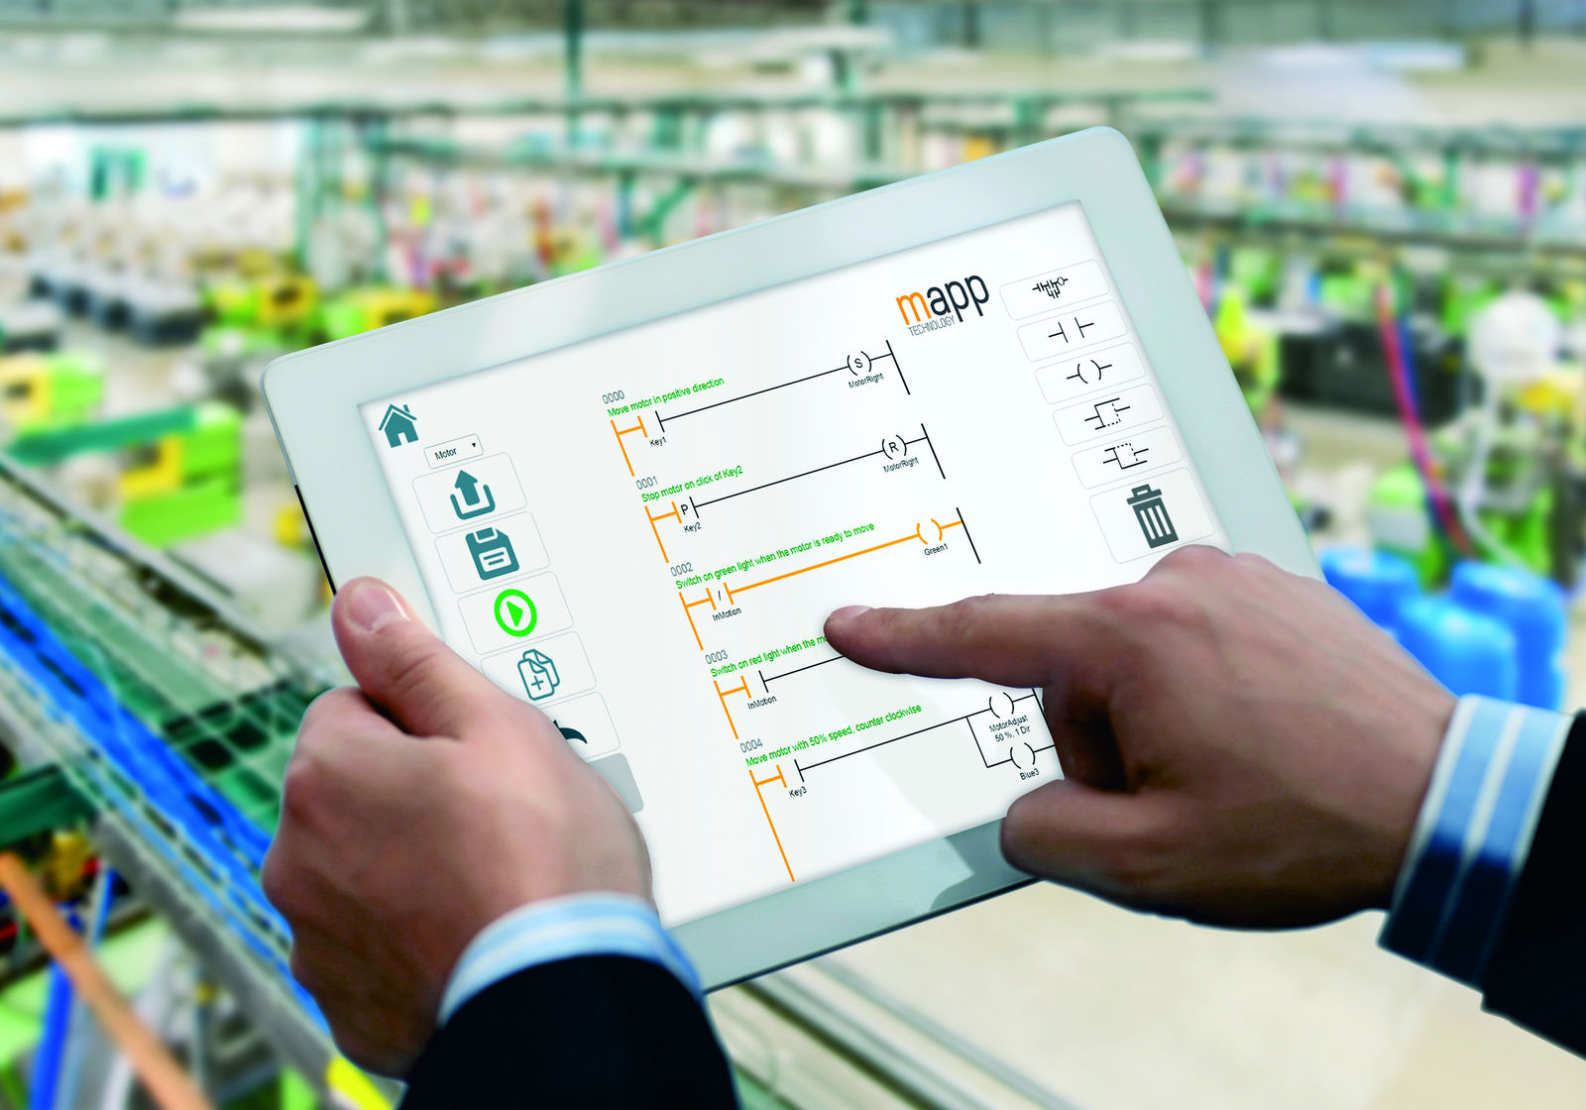
Program machine options easily in ladder logic with B&R's HTML5 tool – mapp CodeBox.

About B&R
B&R is an innovative automation company with headquarters in Austria and offices all around the world. On July 6, 2017, B&R became a business unit of the ABB Group. As a global leader in industrial automation, B&R combines state-of-the-art technology with advanced engineering to provide customers in virtually every industry with complete solutions for machine and factory automation, motion control, HMI and integrated safety technology. With Industrial IoT communication standards like OPC UA, POWERLINK and openSAFETY as well as the powerful Automation Studio software development environment, B&R is constantly redefining the future of automation engineering. The innovative spirit that keeps B&R at the forefront of industrial automation is driven by a commitment to simplifying processes and exceeding customer expectations.
For more information, visit www.br-automation.com.

