Industrial Ethernet now on Raspberry Pi2
Kalycito implements POWERLINK on newest single-board computer
POWERLINK is the first industrial Ethernet protocol to work on the new Raspberry Pi2. Kalycito has implemented openPOWERLINK master and slave with Linux on the 2nd generation of the single-board computer. Raspberry Pi2 was introduced in the spring of 2015 and offers a new dimension of performance on this well-known platform.
Kalycito has come up with a demo that showcases how POWERLINK on Raspberry Pi2 can be an interesting platform for networked industrial and home automation projects to be applied using devices like PLCs and distributed I/O. It should be noted that the demo was created using the unmodified official open source release package. The quick start guide and prebuilt demo binaries can be used to get started before proceeding to modify the C programs for transmitting and receiving data via the I/O pins.
This demo shows how easy it is for anyone to set up and run openPOWERLINK on the Raspberry Pi2 to build their own distributed automation platform and control the signals of motors, sensors, actuators, relays and more. More information regarding this demo can be found at http://www.ethernet-powerlink.org/en/raspberrypi2/.

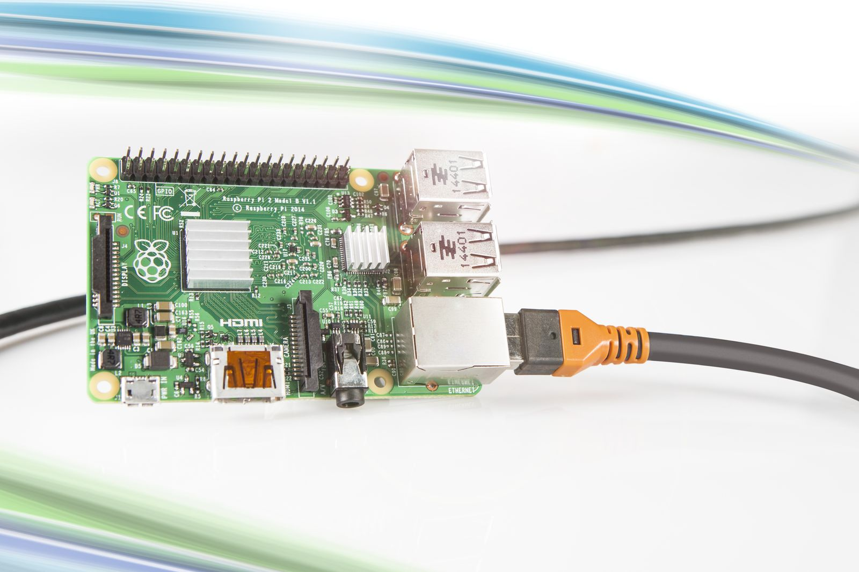
Kalycito has implemented POWERLINK on a Raspberry Pi2 with Linux.

About B&R
B&R is an innovative automation company with headquarters in Austria and offices all around the world. On July 6, 2017, B&R became a business unit of the ABB Group. As a global leader in industrial automation, B&R combines state-of-the-art technology with advanced engineering to provide customers in virtually every industry with complete solutions for machine and factory automation, motion control, HMI and integrated safety technology. With Industrial IoT communication standards like OPC UA, POWERLINK and openSAFETY as well as the powerful Automation Studio software development environment, B&R is constantly redefining the future of automation engineering. The innovative spirit that keeps B&R at the forefront of industrial automation is driven by a commitment to simplifying processes and exceeding customer expectations.
For more information, visit www.br-automation.com.

