B&R on course for expansion and growth
2014 ends with record sales – automation specialist expands globally
B&R hit record sales of €535 million in 2014 for an impressive 13 percent growth. "We intend to continue on this course for expansion," announced general manager Peter Gucher at the company's international press conference, held in mid-April in Hanover, Germany.
B&R's growth has been evenly distributed across Europe, America and Asia. Recent months have seen the addition of new subsidiaries in Japan and Singapore, as the company simultaneously continues to fortify its presence in existing European and American markets. New offices will soon be opening in Europe as well as in Central and South America.
"We're continually founding new subsidiaries and opening new local offices to further strengthen our market position," explains Gucher. B&R serves European and American machine manufacturers with production sites on all five continents. "In India, the partner country for this year's Hannover Messe exhibition, we have established ourselves among the top three suppliers of automation solutions."
Growth market: India
P. V. Sivaram, managing director of B&R India, points out the important role played by India in B&R's overall strategy. The Indian economy is experiencing rapid growth, with the processing industry growing twice as fast as the GDP. "Over the next few years, the share of Indian industrial goods on the global market will increase disproportionately, and with it the demand for automation technology among India's machine manufacturers," predicts Sivaram. "We are ready to satisfy this demand."
Innovations for Industry 4.0
"Modularity, flexibility and across-the-board integration have been the hallmarks of B&R automation systems for many years," explains Gucher. "As a result, B&R's customers are already ideally equipped to handle the challenges of Industry 4.0." As the perfect tools for the job, Gucher points to B&R's universal automation software, Automation Studio, and its process control system, APROL – in addition the company's latest innovations, mapp technology and the 3-axis ACOPOS P3 servo drive. B&R recently set another milestone with the introduction of reACTION technology for safety applications. "We are very proud to offer the world's fastest programmable safety technology," says Gucher.
With APROL, B&R is broadening its focus to include not only machine and systems manufacturers, but plant operators as well. "With our ready-to-use solution packages, we offer user-friendly solutions for process data acquisition, condition monitoring and energy monitoring," says Gucher.

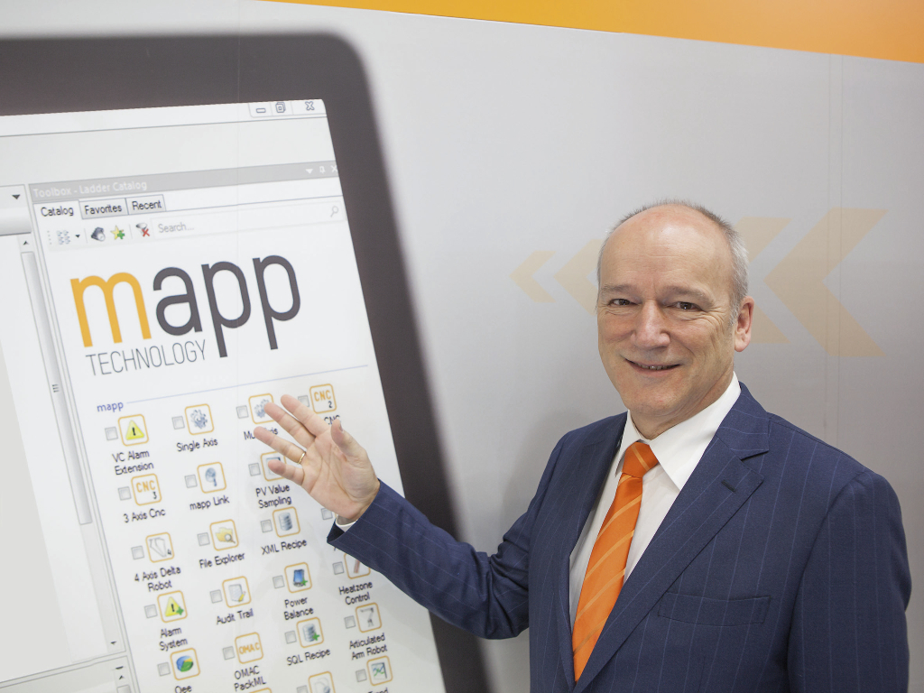
B&R General Manager Peter Gucher: "Our innovations have helped us to considerably increase B&R's market share."
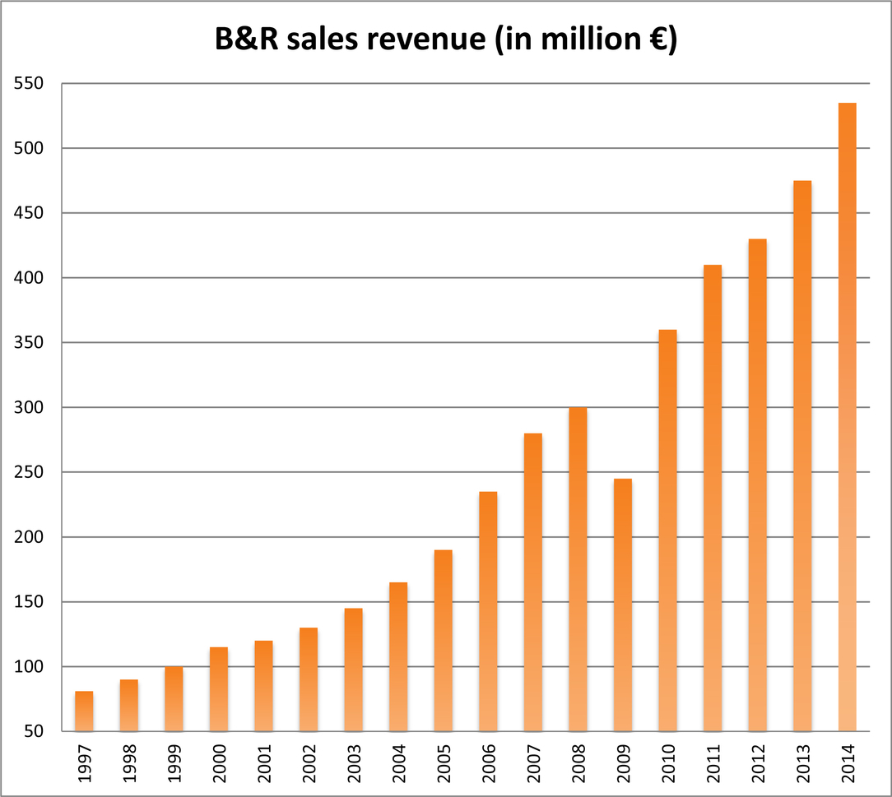
In 2014, B&R achieved sales revenue over €500 million for the first time.

About B&R
B&R is an innovative automation company with headquarters in Austria and offices all around the world. On July 6, 2017, B&R became a business unit of the ABB Group. As a global leader in industrial automation, B&R combines state-of-the-art technology with advanced engineering to provide customers in virtually every industry with complete solutions for machine and factory automation, motion control, HMI and integrated safety technology. With Industrial IoT communication standards like OPC UA, POWERLINK and openSAFETY as well as the powerful Automation Studio software development environment, B&R is constantly redefining the future of automation engineering. The innovative spirit that keeps B&R at the forefront of industrial automation is driven by a commitment to simplifying processes and exceeding customer expectations.
For more information, visit www.br-automation.com.

