Humans and robots, hand in hand
B&R presents new solutions at Anuga FoodTec
New solutions for cooperation between humans and robots in the food and beverage industry will be the focal point of B&R's exhibit in Hall 7 / Booth 39 at the Anuga FoodTec trade fair being held March 24-27 in Cologne, Germany.
"Our SafeROBOTICS functions eliminate the need for a safety cage and allow robots and human operators to work hand in hand," explains Enrico Paolucci, B&R's global account manager for the food and beverage industry. In addition to the already well-established functions for monitoring the speed of a robot's joints and tool center point (TCP), B&R's range of SafeROBOTICS functions has been expanded to include monitoring of workspace boundaries and the orientation of the tool mounting flange. "This makes it even easier to achieve the higher levels of flexibility and tighter integration of robotics and automation demanded by Industry 4.0."
"With the fourth industrial revolution, the complexity of production processes is growing rapidly," says Paolucci. In an effort to adapt to these new challenges, food and beverage companies are increasingly turning to automation technology. "That's why we're making our first appearance at Anuga FoodTec this year." B&R offers food and beverage producers integrated automation solutions that can increase their competitive edge as they transition to Industry 4.0.

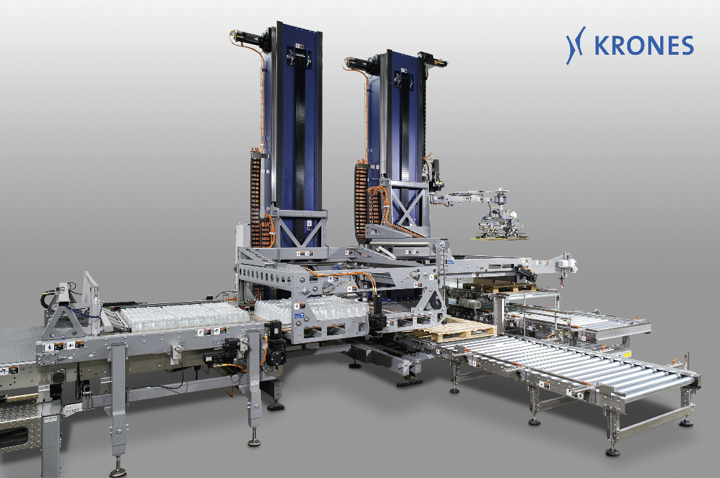
B&R technology provides the high degree of production flexibility essential for companies in the food and beverage industry to meet the challenges of the future. A control and drive system from B&R allows this palletizer to react to changes in the production process – flexibly and fully automatically. Photo: KRONES AG

About B&R
B&R is an innovative automation company with headquarters in Austria and offices all around the world. On July 6, 2017, B&R became a business unit of the ABB Group. As a global leader in industrial automation, B&R combines state-of-the-art technology with advanced engineering to provide customers in virtually every industry with complete solutions for machine and factory automation, motion control, HMI and integrated safety technology. With Industrial IoT communication standards like OPC UA, POWERLINK and openSAFETY as well as the powerful Automation Studio software development environment, B&R is constantly redefining the future of automation engineering. The innovative spirit that keeps B&R at the forefront of industrial automation is driven by a commitment to simplifying processes and exceeding customer expectations.
For more information, visit www.br-automation.com.

