Homing once is enough
New safety functions for B&R's servo drive family
With SafeMOTION Release 1.9, B&R has updated the safety functions for the ACOPOSmulti servo drive family. In addition to two new functions – Remanent Safe Position (RSP) and Safely Limited Acceleration (SLA) – this update also introduces machine options for SafeMOTION parameters and improves both system availability and user-friendliness.
In order to obtain a safe absolute multi-turn position, homing used to be necessary each time an axis was restarted. In some situations, this can require considerable effort, especially for complex multi-axis systems. The Remanent Safe Position (RSP) function allows SafeROBOTICS SLS, SLP and SLO functions to be used without homing after every power-on cycle.
Closer to the limit
The Safely Limited Acceleration (SLA) function monitors the acceleration or deceleration of an axis. If the limit being monitored is exceeded, the SafeMOTION module goes into an acknowledgeable error state.
Using the SLA safety function for coupled axes, for example, makes it possible to significantly reduce the maximum remaining distance an axis will move in the event of an error. The speed limit set in the SLS SafeROBOTICS function can thus be configured closer to the point where there is real danger.
Transfer parameters easily
When commissioning some machines, it is necessary to make machine-specific settings for certain parameters, such as the homing offset or the unit system. You can now use the machine options function to selectively transfer the safety parameters from the functional application to a SafeMOTION module. These safe machine options can be used to update parameters, for example via the HMI application on the operator panel.

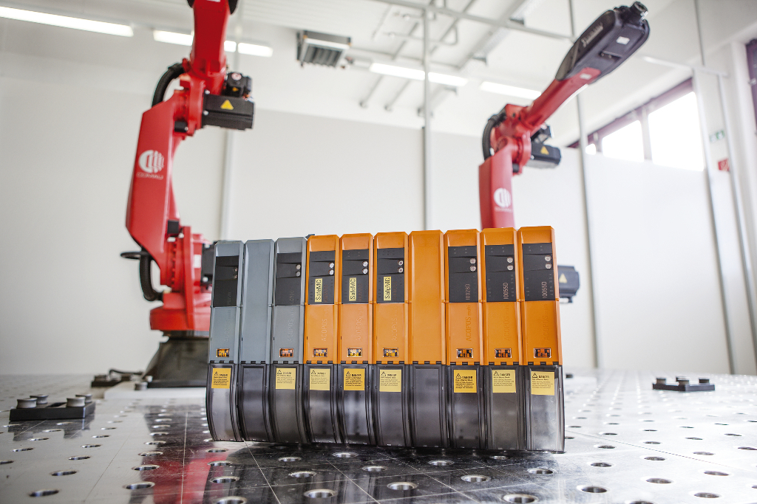
New safety functions for B&R ACOPOSmulti servo drives offer many advantages, including no longer having to home robots after a restart.

About B&R
B&R is an innovative automation company with headquarters in Austria and offices all around the world. On July 6, 2017, B&R became a business unit of the ABB Group. As a global leader in industrial automation, B&R combines state-of-the-art technology with advanced engineering to provide customers in virtually every industry with complete solutions for machine and factory automation, motion control, HMI and integrated safety technology. With Industrial IoT communication standards like OPC UA, POWERLINK and openSAFETY as well as the powerful Automation Studio software development environment, B&R is constantly redefining the future of automation engineering. The innovative spirit that keeps B&R at the forefront of industrial automation is driven by a commitment to simplifying processes and exceeding customer expectations.
For more information, visit www.br-automation.com.

