The B&R network continues to grow
B&R opens a new subsidiary in Singapore
B&R recently founded its 25th subsidiary in Singapore. From the strategically located office, managing director Mark Meng and his team will serve B&R customers across all of Southeast Asia.
"We've built up a strong network of partners in the region over the past few years and are well positioned in the market. It is the right time to step up with a new and promising start," says Meng, who has already been responsible for B&R's activities in Southeast Asia for a number of years. In addition to the city-state itself, B&R Singapore will also serve customers in the surrounding countries, with the main focus on Malaysia, Thailand and Indonesia. Machine manufacturing is a growing industry in these countries, with local companies trying to gain a foothold in the global market.
Always near the customer
B&R Singapore is off to a strong start with a full team of sales, development and support engineers. "Our customers will benefit from the support of our strong local team," says Meng. Our integrated automation technology, known around the world for its exceptional scalability, will help our customers reach their goals and achieve global success."

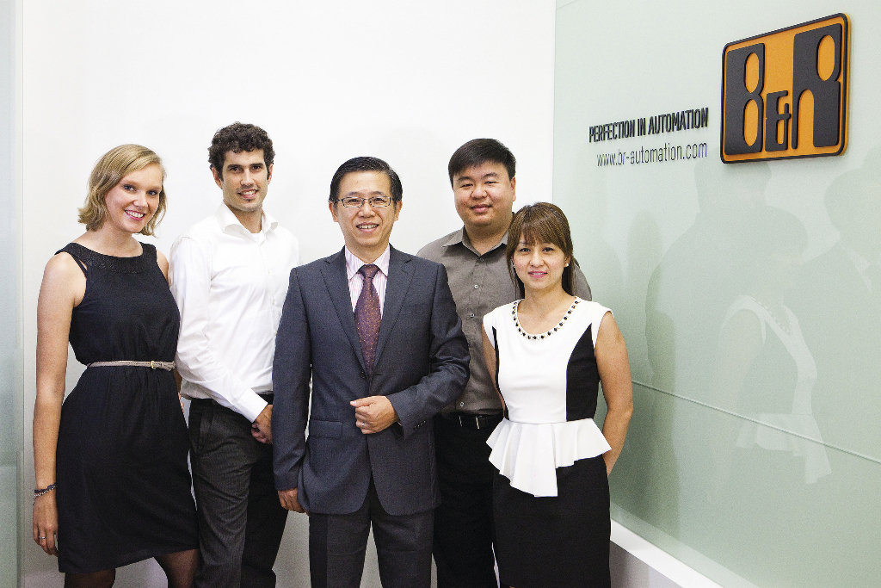
The B&R Singapore team serves the entire Southeast Asia region (from left): Janina Kazmaier, Daniel Sanchez-Munoz, Managing Director Mark Meng, Weishun Goh and Grace Toh.
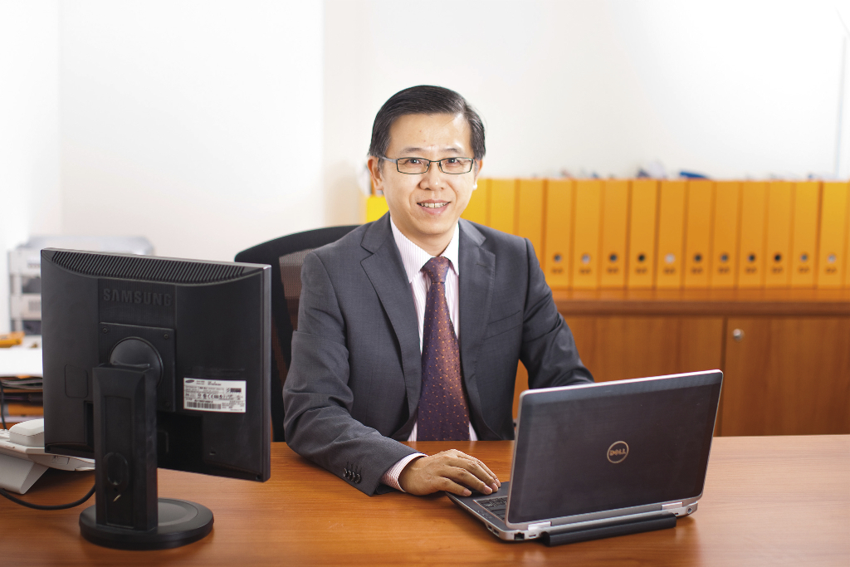
Managing Director Mark Meng heads B&R's 25th subsidiary.

About B&R
B&R is an innovative automation company with headquarters in Austria and offices all around the world. On July 6, 2017, B&R became a business unit of the ABB Group. As a global leader in industrial automation, B&R combines state-of-the-art technology with advanced engineering to provide customers in virtually every industry with complete solutions for machine and factory automation, motion control, HMI and integrated safety technology. With Industrial IoT communication standards like OPC UA, POWERLINK and openSAFETY as well as the powerful Automation Studio software development environment, B&R is constantly redefining the future of automation engineering. The innovative spirit that keeps B&R at the forefront of industrial automation is driven by a commitment to simplifying processes and exceeding customer expectations.
For more information, visit www.br-automation.com.

